STAT Deep Blue Project
(By Archie Shering, St John's Primary School, Richmond)

Introduction
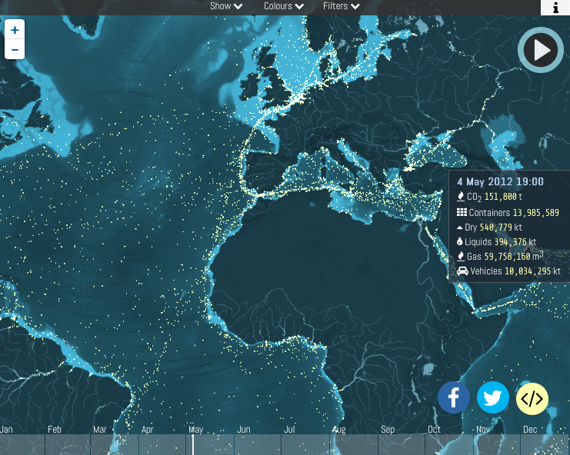
A study showed that 130 million shipping containers were shipped around the world in the year 2016 on 50000 shipping container vessels. Another study showed that between 2008 and 2016 an average of 528 shipping containers were lost at sea each year. That average climbed to 1582 when they included the number lost to catastrophic events (such as hurricanes and ships running aground and sinking).

Once the containers fall off the ship they are very difficult to track down and recover. This means that they are left floating in the oceans. Sometimes they sink to the ocean floor, sometimes they float in the ocean semi-submerged and pose a risk to other boats and sometimes they break apart spilling their contents into the oceans. Many of those contents are dangerous chemicals or plastic goods that are left to pollute the oceans. Every dot is a shipping container

This project will look at trying to solve the problem of semi-submerged shipping containers that pose the greatest risk to other boats at sea. This is because when they are semi submerged they can’t be seen by other boats until they bump into them, often tearing a hole in their hull and damaging the boat and potentially causing the boat to sink.
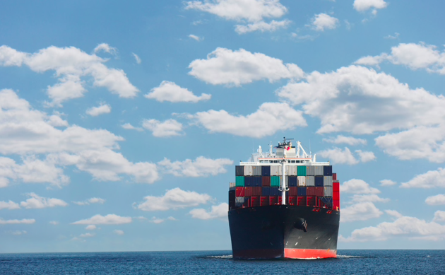

Tracking lost shipping containers

Tracking companies have tried using a variety of tracking methods already. These include GPS or short range wireless radio systems. But there have been limitations to these options.

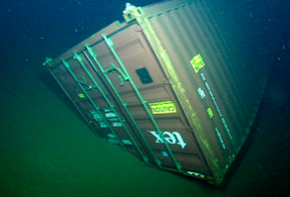
In terms of GPS - the signal cannot penetrate through the steel of the container, so the GPS tracker cannot be concealed safely inside the containers. The devices also need to be able to see the sky for communication with the satellite system, so the signal can often be lost when containers are stacked on top of each other on the cargo vessels. Also, GPS trackers are usually quite power hungry and expensive. Some solar powered GPS trackers have been developed to try and prolong the battery life of the GPS trackers, but if they rely on traditional batteries, the chemicals contained in the batteries are quite toxic as well, so if the battery degrades at sea the chemicals will leak out further polluting the oceans. GPS signals cannot penetrate submerged rocks in the ocean either which may also interfere with receiving the signal from the GPS tracker. Also, GPS trackers communicate by using radio waves. Radio waves do not travel well through water, so if the shipping container was to sink very far below the surface of the ocean, the signal would be lost.

Goal

The goal of this project is to design a radio transmitter system that can be attached to a shipping container’s exterior which would send a signal to nearby boats warning them of a semi-submerged shipping container.

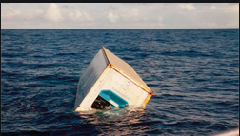

Solution

The ideal solution would be that we are able to use some sort of technology to identify and recover all shipping containers lost at sea. We know that acoustic waves (or sound waves) travel very well through the water and at the moment the US military have commissioned teams of engineers and scientists to try to develop a type of underwater GPS system using buoys and beacons distributed through the ocean. This project is called POSYDON. However the project has encountered difficulty because GPS uses electromagnetic waves which travel very fast, and sound waves travel much more slowly and the speed of their travel will be affected by how salty the water they are travelling though is. Also, they would need to send out a soundwave that would not interfere with the navigation and communications systems of underwater animals such as whales.

So because this technology is not yet available, I have looked at developing a solution to address only those semi submerged containers that pose the greatest risk to other boats using the oceans.

I am proposing that I design and develop a radio transmitter unit, similar to those used to track eagles or whales in other fields of science, that will float above the semi submerged shipping containers, permanently transmitting a radio signal that can be picked up by the AIS system (automatic identification system) already being used on the chart plotters and navigation systems on every boat/ship. The semi submerged shipping container would then identify itself as another boat on the chart plotter of an approaching boat which the skipper would then (hopefully!!) avoid as usual.

A system that uses radio frequencies is much cheaper to run than a GPS system. It is also much less power hungry using only 12-15mA of current to transmit a signal as opposed to the 14-30mA of current used by GPS. This makes it much more possible for a solar rechargeable battery to be fitted to the unit which will be sufficient to keep the transmitter charged while at sea.

One of the limitations my design would have to address is that the radio frequency can’t transmit under water, so I would need to fit some sort of a floatation device to the unit to make it sit back up on the surface of the water where it can transmit its signal properly. This would need to be attached to the shipping container by some sort of high tensile string or cable that would be released from its housing on the shipping container when a salt water activation switch is triggered by the container falling into the sea (just like those used on automatically inflating life jackets that are already available). To prevent this string becoming tangled around the shipping container as it rolls in high seas I would need to fit the cable to the container using a multi-directional pivot so the container could roll around under the transmitter without disturbing the signal or tangling up the cable.
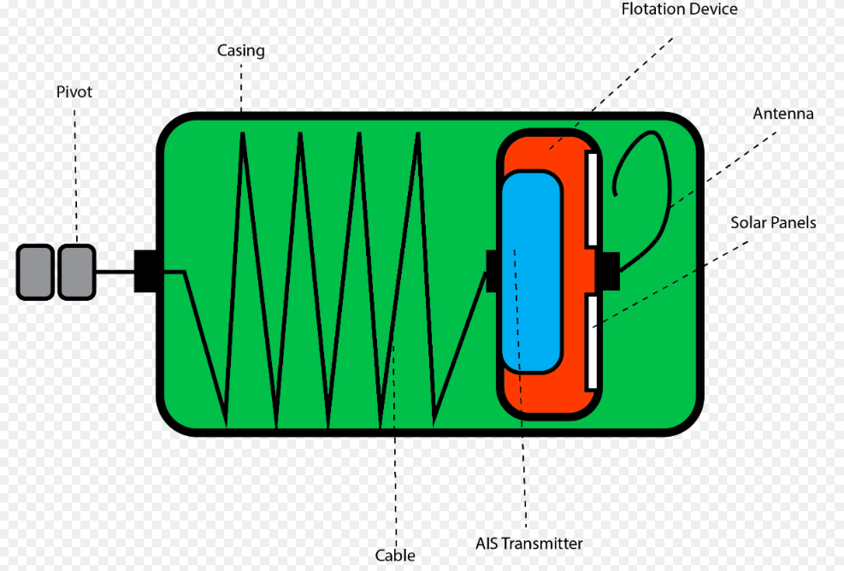
Images made from Adobe illustrator by Archie Shering
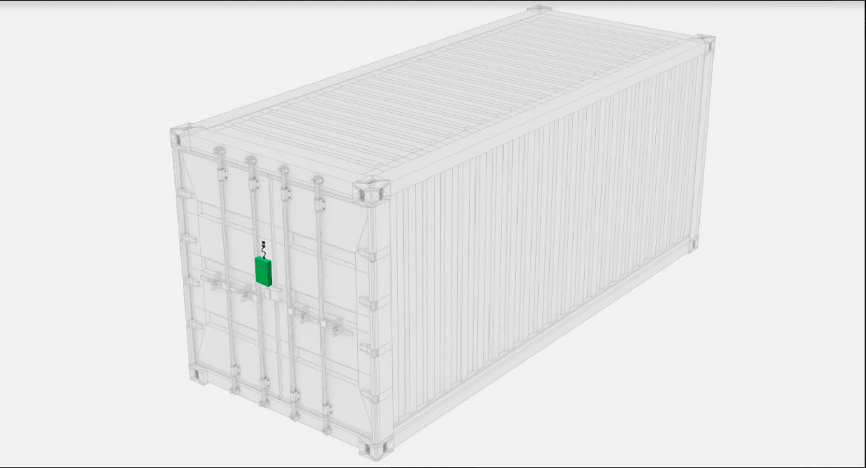

Safety concerns

Two safety concerns that I have identified with my transmitter are:

- Potential tangling of wildlife (such as whales and dolphins) in the cable and float raising the transmitter to the surface of the water. I am hoping the pivot will reduce this risk by the cable turning around the pivot on the shipping container rather than turning around the animal swimming around it.

- The potential leaking of the toxic chemicals from the battery powering the transmitter if the casing or battery degrade at sea. I am hoping that if the casing is water tight enough this will be much less of a risk. Again this would have to be tested for before the transmitter could be used commercially by shipping companies

- The potential for the propeller of a boat’s engine to become tangled in the cable attached from the container to the float. I am hoping that limiting the length of the cable to 10m will reduce this risk sufficiently as boats at sea would not want to pass within 10m of each other so if the transmitter has been on identified on your AIS system as you approach the container and float you would be avoiding it anyway. This would need to be tested properly before I could roll the device out to all shipping containers
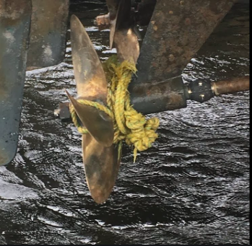

Testing my model

I would set up a test of my model by hiring a big deep diving pool and dropping a shipping container into it so that it would be semi submerged and seeing if the unit works as I expect it to. It would let you repeatedly test for the device‘s housing being properly waterproof, checking that the battery cant leak in a controlled environment without polluting the ocean and check that all the components on the device are working properly - like the pivot. You could set up a system to tumble the container and test the cable isn’t being tangled and that the transmitter floats back up to the surface properly.

Once testing in this very controlled environment is finished I would be able to take my model out to a part of the ocean that isn’t a protected marine environment and run the same sort of tests at sea to check all components of the device again. Modifications to the design would be based on the information and results of this testing process.

I think some of the strengths of my design are:
- Using AIS means all boats already have alert systems to prevent collisions with the container
- Relatively inexpensive components to build the transmitter device, especially compared to GPS
- A longer battery life due to less power used by radio transmitter compared to GPS
- The pivot system to prevent the cable tangling and no longer allowing the transmitter to float on the water surface
- Uses already existing technology (the AIS system used by all boats navigation systems, radio transmitters, solar panels, long life batteries) - making it more readily accessible to the boats we are trying to prevent being damaged

I think some of the weaknesses of my design are:
- Shipping companies aren’t motivated to invest in this device for all their thousands of shipping containers as there are currently no financial consequences to the shipping companies or the insurers for just abandoning their lost containers, so who would pay for this device
- If the container sinks the radio signal will be lost. If the container remains sunk this isnt such a problem as the container is no longer a threat to passing boats, but if it is only temporarily submerged by high seas or rough weather it may be more of a problem until the weather passes and the float can return the transmitter to the surface of the water.
- The potential for a passing boat’s propeller to become tangled in the cable. This is why I have kept the cable to 10m in length only so that is less likely. If you are out sailing in your boat you are unlikely to want to pass within 10m of another passing boat identified on your AIS system
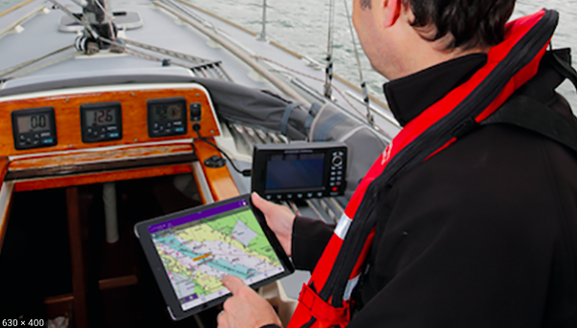

Future Possibilities

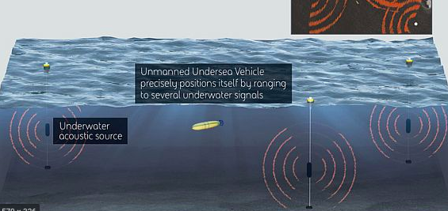
The POSYDN system being developed by the US military would be the best solution long term once the technology has been sufficiently developed. This would allow not only the semi submerged containers to be identified and recovered but all lost containers to be recovered and the many risks and threats to be removed from the ocean from all lost shipping containers.

The POSYDON system -->

References

https://www.shippingandfreightresource.com/containers-lost-at-sea/#

https://www.relegen.com/blog/shipping-container-contents-track-and-trace-challenges/

https://www.telegraph.co.uk/travel/travel-truths/lost-container-ships-bizarre-world-of-global-shipping/

https://www.theatlantic.com/technology/archive/2016/06/its-gps-underwater-for-robots/486656/

https://dosits.org/galleries/technology-gallery/navigation-technology/underwater-gps/

https://singularityhub.com/2011/04/05/10000-shipping-containers-lost-at-sea-each-year-heres-a-look-at-one-2/

https://www.theatlantic.com/technology/archive/2016/06/its-gps-underwater-for-robots/486656/

https://link.springer.com/article/10.1007/s00190-018-1147-x

https://hikinggpszone.com/how-much-battery-does-gps-use-and-how-to-make-it-last/

https://ocean.si.edu/human-connections/exploration/whale-tracking-device

https://www.fisheries.noaa.gov/feature-story/tracking-technology-science-finding-whale/

https://www.whalenet.org/satellite-tracking/how-satellite-tags-work/

http://www.seaturtle.org/tagging/satellite.shtml

https://biopixeloceans.org/guide-tracking-tagging-part-3-3/

https://www.advancedsciencenews.com/salt-water-battery/

