In this essay I will be explaining the topic of plastic pollution and explaining causes, effects, and solutions to the growing amount of plastic that is troubling the environment and at the end explain my point of view of weather plastic pollution is a good or bad thing. Plastic pollution is when plastic afflicts the land, oceans and other waterways causing pain and suffering of many animals and cause some health concerns to us humans. The main reason why plastic pollution is significant I because it can take thousands of years for these different plastic objects to decompose.
Causes:
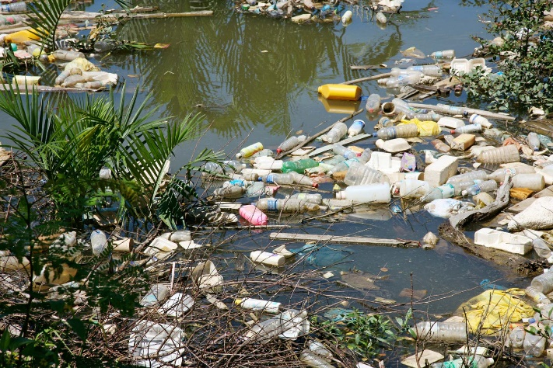
Some of the causes of plastic pollution are plastic trash, many of the things that we throw away are plastic produced products and when you throw that kind of rubbish out, it would most of the time go into trash dumps or landfill and when that happens it allows the toxic pollutants that are in plastic products to enter the ground and affect the animals and the ground water in those areas. Another reason of plastic pollution is that plastic products are overused way too much, plastic is less expensive than other products and it is one of the most used and overused item in the world today. Most of the things that are used in everyday life are the things that would otherwise be put in landfill and like I said when they go into landfill it lets the plastic pollutants into the environment.
Another thing that helps with the growth of plastic pollution is fishing nets, why fishing nets are a big reason is that most if not all fishing nets are made out of plastic. Whenever people use the nets for fishing it leaks plastic pollutants into the oceans and damages its ecosystem. The final thing that causes plastic pollution is the way that we dispose of plastic and garbage, some might be confused when I say this because some might think that plastic is supposed to last and as much as that is true it doesn’t mean that it lasts forever. Because plastic is supposed to last it means that it takes a very long time to decompose, which is bad for the environment because when we put our plastic waste into landfill it can be very bad because of there is a possibility of plastic finding its way into water ways and to go into the oceans and damaging the ecosystem.

Effects:
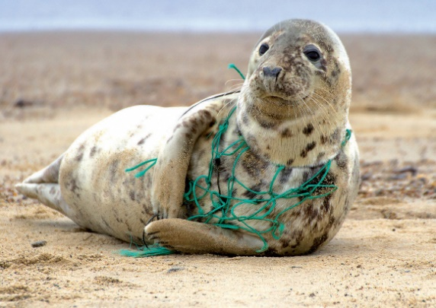
Here are some of the serious effects that are caused by plastic pollution. Firstly, plastic pollution can upset the food chain, because of the array of sizes the plastic products can be, from the little things like straws to the big things like fishing nets and because of the array of sizes even the smallest organisms (plankton) are affected by this problem. Because the smallest organisms in the food chain are affected it also causes the bigger animals that depend on them for food to be affected as well, and because of this the problem then spans to all along the food chain to all animals/organisms.
The second effect is ground water pollution. Groundwater pollution is when bad pollutants are released and enters the ground and find their way into the under-ground waterways polluting it. Groundwater pollution is already worried about in some countries around the world and this only adds more stress on this concern. The groundwater problem can also affect the water in streams, rivers and the oceans and can damage not only the environment but also make the animals that live in these areas very sick and can cause the animals that consume these sick animals sick as well and this problem can spread very quickly.
Another effect is land and air pollution, land pollution is when the plastic that gets dumped into landfill and then comes in contact with water and then creates hazardous chemicals, then those chemicals seep into the ground and they degrade the quality of the under-ground water. It is also when the wind carries the plastic from one place to another and increases the plastic litter that is already in those areas and this then increases the chance of animals coming in contact with them and suffocating these animals to death. Air pollution is when plastic products are burned in open air that then releases and allows poisonous chemicals enter and pollute the air and then it gets consumed by people and animals and can cause them to have health and respiratory problems.

Plastic pollution can also affect animals by killing them. Plastic pollution can kill animals because when plastic products are left in the water ways like streams, rivers and oceans that can be eaten by animals that mistake them for food and can cause them to be unable to eat and they starve or they can suffocate to death, animals can also get tangled in the plastic and can cause them to be unable to swim away and this can be fatal for animals like dolphins and other marine mammals because they need to go to the surface regularly in order to breath, so they can’t stay underwater every long. The last effect that I have for you is that we waste millions of dollars each year that is spent to clean up the affected areas, it also causes the loss of life for plants, animals, and people. And as land becomes more valuable, it becomes harder to find places to throw away our trash, and the areas affected also get less tourism than the other areas.
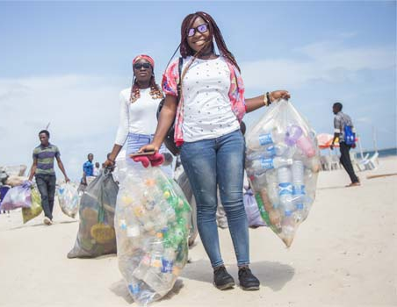
Solutions:
Here are some of the affective solutions that we can imply on our lives. Firstly, we can shop more friendlier by using reusable bags, many which can be transported more easily, and it also helps to lessen the usage of one time use plastic bags, that is one of the biggest causes of plastic pollution. Secondly, we can stop using bottled water in plastic bottles that are for one use only and instead use reusable water bottles. We can also stop using go-to containers because a lot of plastic goes into the making and packaging of these plastic products, things like take-away coffee cups that you might think are just paper but actually most likely are lined with plastic for insulation. Instead of using some of the containers, lids and utensils that are for only one use, we should really replace them with reusable containers, water bottles and other utensils, so that you can cut down significantly on even one meals waste!
Another thing that would greatly help the cause would be to educate businesses like restaurants and other local businesses and to tell them about all the options that they can switch to that can help the environment instead of the plastic alternatives. Another solution is to get involved by talking to the lawmakers of your communities to help to encourage that the use of plastic should be more limited in the community and do this by proposing the development of alternative items and other ways to lessen plastic use. Lastly, you can recycle everything by trying and select items that come in non-plastic recycled and recyclable packaging, properly handle item that cannot be reused/recycled and to check everything before putting it in the trash. You can also help by cleaning the affected areas of land and water from these plastic products.
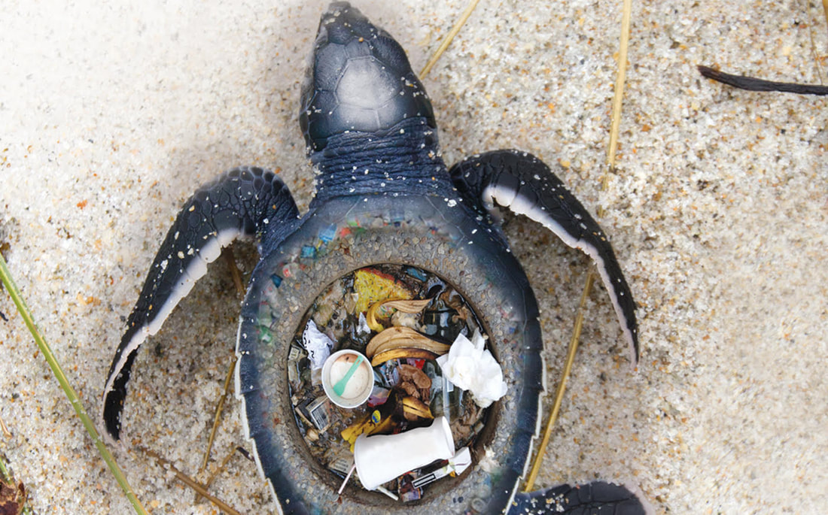
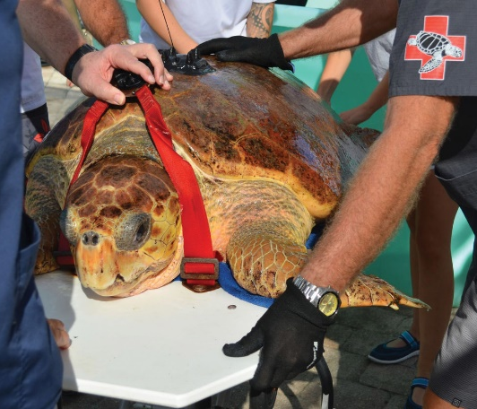
In conclusion to all these facts that I have told you about and my perspective on this plastic pollution problem is that it is very bad not only for us but for everyone around us and we know that we each have the individual responsibility to look after and protect the other people and animals around us. So, we already know that we are to try our best to help this cause not only for the people and animals of today but also to the ones in the days to come. I have already showed you all what plastic pollution can do to us and animals, so I implore you to help not only yourself and your families but everyone else around the world.
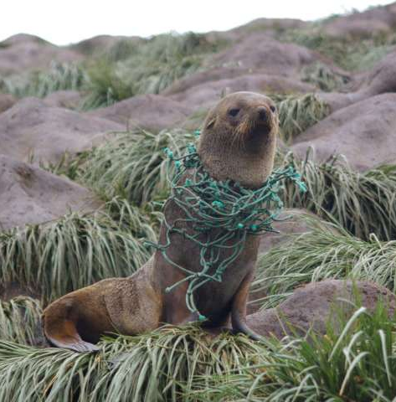
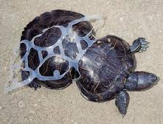

Info Reference-
- Causes, Effects and Solutions of Plastic Pollution - Conserve Energy Future. (2015). Retrieved 1 June 2020, from https://www.conserve-energy-future.com/causes-effects-solutions-of-plastic-pollution.php
Pic References-
- plastic pollution | Sources & Effects. (2020). Retrieved 2 June 2020, from https://www.britannica.com/science/plastic-pollution
- Chatterjee, S., & Sharma, S. (2019). Microplastics in our oceans and marine health. Field Actions Science Reports. The Journal Of Field Actions, (Special Issue 19), 54-61. Retrieved from https://journals.openedition.org/factsrepor

Join the wave. (2020). Retrieved 4 June 2020, from https://oceanconservancy.org/trash-free-seas/international-coastal-cleanup/volunteer/

Guidelines for Safely Transporting Sick or Injured Sea Turtles — The State of the World's Sea Turtles | SWOT. (2019). Retrieved 4 June 2020, from https://www.seaturtlestatus.org/articles/2019/1/31/finding-the-keys-to-safe-transport-of-debilitated-turtles

