|  |  |  |  |
| --- | --- | --- | --- |
|  |  |  | |
| ***STATIC*** | | | |
| ***The Newsletter of the Science Teachers Association of Tasmania.*** | | | |
| Macintosh HD:Users:joeekelk:Desktop:STATIC October:CONASTA photos Jill:DSC00097.JPG | | | |
| **2017 in Review** | | | |
| November 2017, Volume 2 | | | |
| [JOEE:AAA STATIC 2 STATIC 2016 FOOD:STAT.jpg](http://stat.org.au) | | |  |
|  |

**STAT Council Members**

|  |  |
| --- | --- |
| **President and ASTA Council Representative**  Rosemary Anderson  DOE Curriculum Services, Hobart | **STAT**  **PO BOX 1112**  **Sandy Bay TAS 7006**  [STATcouncil@gmail.com](mailto:STATcouncil@gmail.com) |
| **Vice President and Membership Officer**  Jenny Dudgeon  Sustainability Learning Centre, Mt Nelson | **Treasurer, Membership Officer and ASTA council representative**  Jill Reade  Education Faculty, University of Tasmania, Launceston |
| **Minute Secretary**  Darrin Timms  East Launceston Primary School | **Assistant Treasurer**  Sonya Matthews  Prospect High School, Launceston |
| **Operational Secretary** Doug Grubert  Launceston Church Grammar | **Awards Officer**  Ann Burke  Marist College, Burnie |
| **Digital Communications and National Science Week contact**  Denise Devitt  [Hobart](mailto:Denisedevitt@hotmail.com) | **University of Tasmania** Faculty of Science Engineering & Technology Representative  Jeannie-Marie LeRoi  University of Tasmania, Hobart |
| **Professional Learning/TSTS Co-ordinator**  Marj Colvill  Launceston | **General Councillor**  Bruce Duncan  University of Tasmania, Hobart |
| **PL and TSTS Committee Chair**  John Bardenhagen  East Launceston Primary | **General Councillor**  Fiona Phillips Newstead College, Launceston |
| **STATIC Editor**  Joee Kelk  Riverside Primary School and University of Tasmania, Launceston |  |
| ***STAT Activities are managed by a small group of volunteers who are happy to provide further information. If you would like to become involved with this dedicated and professional support group of teachers then let us know. Every science educator in the state is most welcome and science needs you!*** | |

**Contents**

*This is an interactive Contents page – click the page number to go straight there!*

From the Editor 4

2018 Science Week Theme 4

Get Social with STAT 4

Science Investigation Workshop – November 2017 5

The Art of Science: CONASTA 66 6

From CONASTA 66 With Love 7

CONASTA 66 – Experiences of a beginning teacher 8

CONASTA 66 in Hobart 10

2018 Science Teaching Conference in Burnie 11

2018 Agricultural Educators Conference in Launceston 12

Science Week – Collinsvale Primary 13

Future Earth: Future Lauderdale Primary School 13

STEM Shines at East Launceston Primary 14

Amplify STEM at Invermay Primary School 15

A STEM Investigation in Kindergarten 16

Amplify STEM at Sandy Bay Infant School 17

Amplify STEM at Lansdowne Primary School 18

ASTA Teacher Exchange to Japan 21

Teachers visit Japan to transform their STEM teaching 22

The STEM X Academy: A personal account. 23

2018 Festival of Bright Ideas – Date Saver 24

F1 in Schools: Involving your primary aged students 25

STAT Membership 2018 - Heads Up 26

Open Letter on Copyright 27

Tasmanian Science Talent Search in 2017 28

TSTS Results -Engineering and Research Investigations 28

# Macintosh HD:Users:joeekelk:Desktop:STATIC October:CONASTA photos:Conasta Selfie.jpgFrom the Editor

It’s been a big year for STAT. Hosting the National Science Teachers Conference (CONASTA) in Hobart was the focus of a lot of council time and energy. This edition contains first hand reports from the teachers who were awarded STAT scholarships to attend. By the look of their reviews it was a great time, taking in MONA, UTAS, IMAS and a range of other Hobart delights to explore the Art of Science.

There are also a few reports from schools that undertook Science Week activities, and other STEM focussed displays such as the Amplify STEM programs. There are date savers and theme announcements for several conferences and other events coming up in 2018 so that you can add them to your calendar straight away. And on top of that there are a few pieces of information that have drifted in from ASTA.

2018 is fast approaching. The dates and themes for STATIC have not yet been finalised but all STAT members will receive an email when they are. And as always, keep your eyes on your inbox and social media for important announcements to do with STAT and PL.

Joee.  
STATIC Editor 2017.  
[editorstatic@gmail.com](mailto:editorstatic@gmail.com)

# 2018 Science Week Theme

|  |  |
| --- | --- |
| National Science Week has released the schools theme for 11-19 August 2018 – “Game Changers and Change Makers”.  “This could refer to individuals, teams, technologies or ideas – what does it suggest to you?” |  |

# Get Social with STAT

|  |  |  |  |
| --- | --- | --- | --- |
|  | | | |
| [***Facebook Group***](https://www.facebook.com/groups/129010120575185/) | [***Twitter***](https://twitter.com/STATasmania) | [***Facebook Page***](https://www.facebook.com/STAT-Science-Teachers-Association-of-Tasmania-763343113840335/) | [***Instagram***](https://www.instagram.com/stat_science_teachers_tasmania/) |

# Science Investigation Workshop – November 2017

[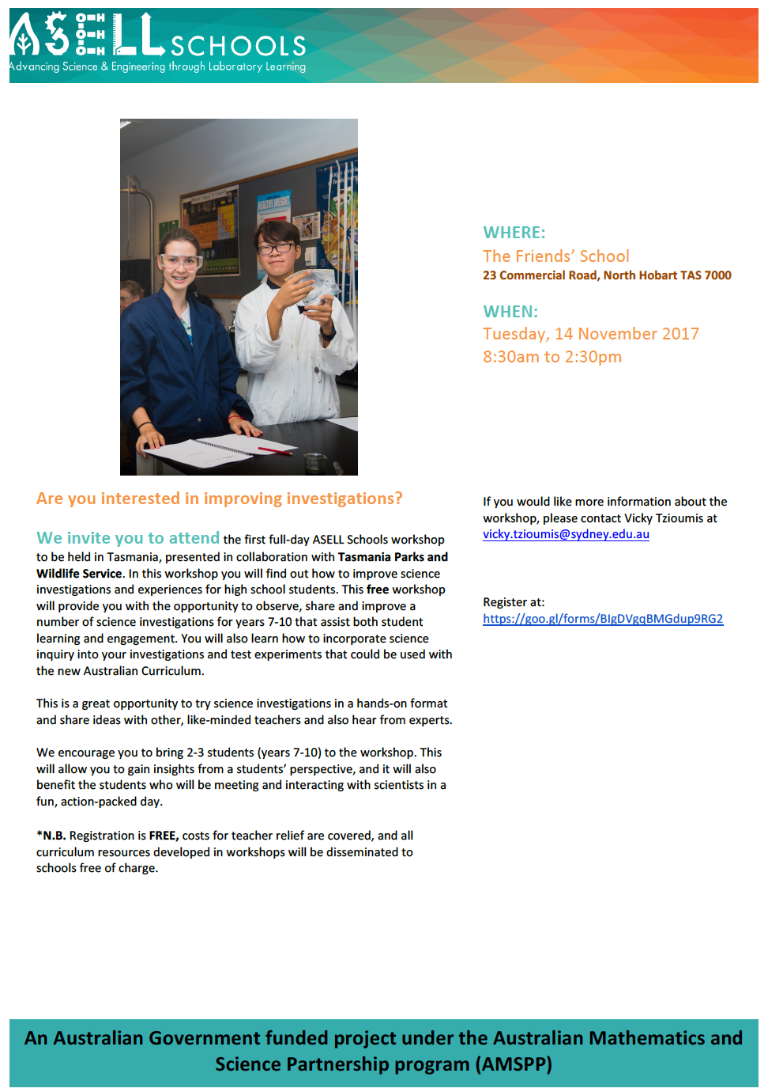](https://docs.google.com/forms/d/e/1FAIpQLSdgSTeQpucbkCtCNdxqOKRKGH0TjrnJQjRAAkibyyI7nvLf_A/viewform)

***Registrations needed by 8 November –*** [***click here to register.***](https://docs.google.com/forms/d/e/1FAIpQLSdgSTeQpucbkCtCNdxqOKRKGH0TjrnJQjRAAkibyyI7nvLf_A/viewform)

# The Art of Science: CONASTA 66

By Sheila Sheriff, Penguin High School.

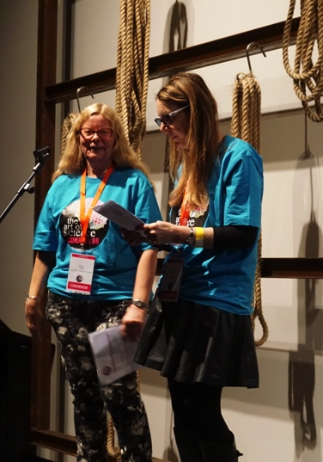July saw a large number of passionate teachers, support staff and other stakeholders attend CONASTA 66, the Art of Science. Like the Beatles painting, there were four different perspectives: Science as Art; Art as Science; the art of doing Science; and the art of teaching Science.

The conference began at MONA where sculptures made of recycled and repurposed materials appear alongside architectural sketches and plans. Later Dr Drew Berry presented his work in animations with molecules and Professor Brigid Haywood explained her work in crystals. Both highly accredited scientists could exhibit alongside accomplished artists without appearing out of place.

A number of artists presented at the conference advocating for the integration of the Arts into Science classes. It was said that both disciplines follow a similar approach to producing and displaying information, require creativity and the ability to communicate to an audience who may not clearly understand the perspective of the author. The inclusion of artsy students by allowing them to see the integration of the methods is thought to help remove some of the barriers and open up richer learning opportunities for all young people.

Several passionate scientists walked through their findings the result of years of research. Their methods and passion rivalled that of passionate artists. Dr Beth Fulton outlined her vast experience in the field and some of her findings with CSIRO. Professor Greg Woods explained Devil Facial Tumour Disease and how they were able to discover different strains of the disease through DNA sequencing. At one stage both of these accomplished people were students in a classroom and that should be incredibly encouraging to teachers. We do not know who will become leaders in the field of Science.

Finally, many generous teachers shared their experience, resources and ideas for engaging students in Science. Olivia Belshaw from Jindabyne ran a workshop on catering for gifted students. She set up a Google drive that contained resources for extending students and allowing them to explain their thinking. Glen Pusey narrated his journey with STEM clubs giving students at his school, Churchlands, an opportunity to pursue their passions in technology alongside their regular classes. Bruce Duncan from UTAS had a room filled with educators fascinated by a bottle of soda water and potatoes to prompt a renewed interest in constructivist teaching and creating access for all learners. A testimony by Roland Gesthuizen about his journey from web cam to smart cities provided a real example of the journey one teacher can take down a delightful rabbit hole. The generosity of teachers and the way they perfect their craft is inspiring to see, like all great art, I suppose.

I thoroughly enjoyed my experiences and would like to thank STAT for supporting my attendance.

# From CONASTA 66 With Love

By Roberta Lewis, Launceston College

***“The greatest scientists are always artists as well.” (Albert Einstein, 1923)***

The 66th annual conference of the Australian Science Teachers Association was held in Hobart from the 10th – 12th of July and hosted by our own Science Teachers Association of Tasmania. Over 530 teachers and lab technicians attended the conference.

Internationally recognised and awarded researcher Professor Paulo de Souza set the bar high with the opening keynote session: Exploring Mars. A humorous and engaging speaker, the audience listened intently as we were given the low-down on the Mars Exploration Rovers Project by one of NASA’s participating scientists.

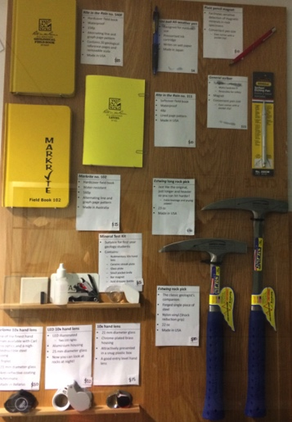One of the highlights for me was an off-site workshop at the University of Tasmania Hobart campus (one of the key sponsors of CONASTA 66) entitled ‘… and you thought you were old’. Presented by Dr Michael Roach, Senior Lecturer in Earth Science, this was a wonderful opportunity to see the variety of instruments used in the radiometric dating of rocks. Now I just have to get my hands on a laser ablation mass spectrometer…

I do have to mention the delicious food provided at CONASTA (it was important to keep up our mental strength!) Mmm… I could eat another dozen of those mini lemon meringue tarts.

The second keynote address was delivered by Professor Brigid Heywood, Deputy Vice-Chancellor (Research) of the University of Tasmania had all of us challenging our ideas about the teaching and delivery of science content to meet the needs of a 21st century society. Of course, she slipped in some information relating to her own field of research, with the defence “I am not biased, I am passionate”. Professor Heywood’s presentation really emphasised the need for teachers to convey that passion for science to our students.

The keynote speakers on Tuesday, Dr Drew Berry and Professor Gustaaf Hallegraeff both gave talks that clearly demonstrated the creativity and beauty in their scientific fields and their enthusiasm “to inspire students with the wonder of the natural world.”

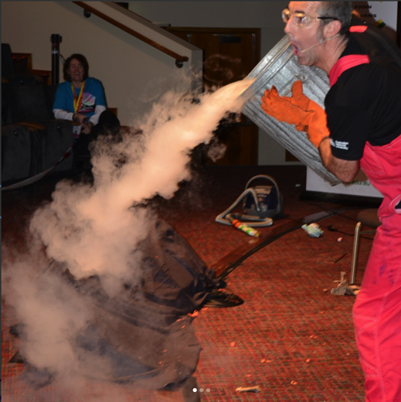After so many fantastic presentations and workshops, it was going to need something special to provide a fitting conclusion to CONASTA 66. Dr Graham Walker did not disappoint. I felt like a kid again as I watched his liquid nitrogen demonstrations, the marshmallow bazooka (I’ve got to try that one in the classroom!!), the burning bubbles, the model combustion engine… he effortlessly intertwined education and comedy and made me re-remember the thrill of discovery, which is really what science is all about. I sincerely thank STAT for supporting my attendance at the conference and look forward to CONASTA 67 in Sydney next year.

# CONASTA 66 – Experiences of a beginning teacher

by Thomas Coad, Rose Bay High School.

In July 2017 Hobart became host to CONASTA 66, a large-scale science-education conference that aimed to provide attendees with professional skills and resources, as well as a glimpse at where classroom science intersects with real-world human endeavour. CONASTA 66’s theme, *The Art of Science*, could not have found a more fitting location. Our picture-perfect city of Hobart, undoubtedly a world leader in various genres of scientific research and home to the Museum of Old and New Art (MONA) set a perfect stage for the event.

Nestled in the shadows of kunanyi, at one end of the Sullivans Cove is CSIRO and the Institute for Marine and Antarctic Studies (IMAS), the ice-breaker *Aurora Australis,* our marine-science flagship, the *RV Investigator* docked alongside, eagerly awaiting discovery. On the opposing side of the harbour sits the University of Tasmania’s prestigious School of the Arts. This does not create disjunction between the arts and science, but rather, it identifies both as being complimentary and essential in society, giving breath to the growing embrace of the collaborative disciplines of Science, Technology, Engineering, Arts and Mathematics (STEAM).

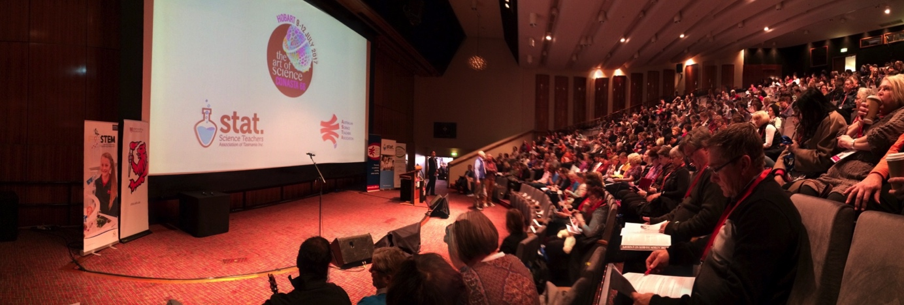

Having already marvelled at the setting for CONASTA 66, I would now like to take this opportunity to reflect on my experiences at the conference on a more personal level. As a beginning teacher, CONASTA 66 has served as my first large-scale science education conference and it did not disappoint. From day one, I was blown away, not only by its sheer magnitude, but also by the calibre of keynote speakers. What better way to open a conference at the frontier of science education, than with the words of keynote speaker, Prof. Paulo de Sousa, a scientist playing a pivotal role in the exploration of the final frontier – SPACE?

Prof. de Sousa spoke of the evolution of Mars rovers over recent decades before detailing his own involvement in the Curiosity Rover missions. Space and astronomy remains a fascinating yet elusive science, perhaps in part due to a perceived disconnect from students’ every day lives. Prof. de Sousa’s vivid explanations and animations proved to be remarkable in bridging this gap between space science at the forefront of human endeavour and the science occurring in Australian schools. Having listened to Prof. de Sousa’s insights, coupled with recent publicity regarding the space probe Cassini’s final moments around Saturn, we could not be teaching science at a more exciting time in history.

Dr. Helen Fitton’s Breakfast address did, however, speak of a science a little closer to home. Attendees marvelled at the medicinal properties possessed by Tasmanian grown seaweeds and how the bioactive compound ‘fucoidan’ has been an area of primary exploration by Tasmanian biotechnology company, Marinova Pty Ltd. Later, audiences admired the biomedical animations from the incredibly talented Dr. Drew Berry and were able to gain an appreciation for the incredible structures formed among the single-celled organisms that fill our oceans, following an insightful presentation by Tasmania’s own Prof. Gustaaf Hallegraeff.

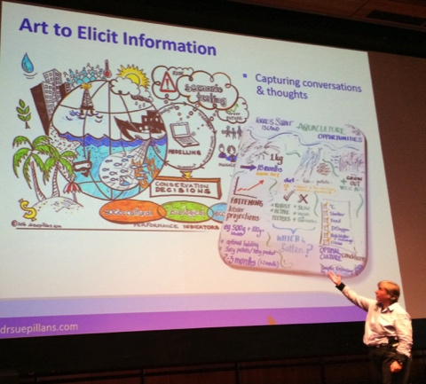Prof. Hallegraeff’s insights came with the humbling reminder that, as humans strive to create grander architectural masterpieces, nature was there first. All mentioned keynotes, as well as many others, were complimented on the final day of CONASTA by the enthusing presentation of Dr. Beth Fulton who reminded us further of the intricate intersection between art and science. She spoke of the inherent beauty that is so deeply embedded in scientific method, a beauty that motivates and consumes both scientists and educators alike.

In addition to the awe inspiring and motivational insights of the keynotes, CONASTA 66 offered an array of hands-on or otherwise, highly informative workshops. I embraced the opportunity to collect a comprehensive repertoire of resources for teaching geological sciences and relished in the array of dynamic methods of communicating geological processes to secondary students, from the simple yet tasty ‘Mars Bar Earth’ to concepts surrounding plate tectonics that could challenge the inherently gifted. If, as an attendee, you held any yearning to understand the planet on which we live, then CONASTA had something for you.

From the concrete reality that is the world we live in, I dove head first into a world of virtual reality (VR). VR remains an emerging educational field, however following a number of stimulating VR oriented workshops, I feel prepared to lead my classroom into the 21st century. Take a guided tour through a cell, follow a hormone through the bloodstream or take a journey through our solar system – it seems that while VR remains in its infancy, the opportunities for VR as an effective educational tool are limited only by one’s imagination.

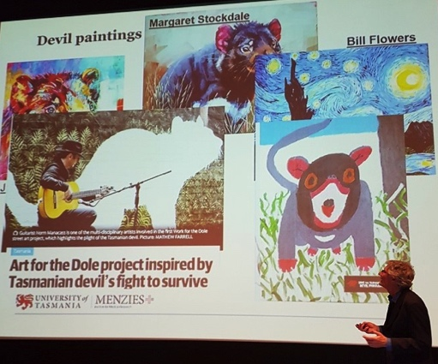Anyone with a background in science or education would attest that collaboration is essential practice, and so whilst the days were filled with collaboration in the sense of sharing resources and developing new skills, the evenings were for networking in the more social sense of the word. It was wonderful to meet educators and scientists from across the nation, to talk about common interests and to discover new ones. The social side of CONASTA 66 certainly assisted in distinguishing it from simply being ‘just another science conference’.

With all things said, my experiences of CONASTA 66 have been invaluable with respect to my development as a beginning teacher and I must offer my sincerest appreciations to the Science Teachers Association of Tasmania for assisting me with the financial means to attend. Thanks CONASTA 66, you’ve been great, but now it is time to bring on Sydney and CONASTA in 2018.

# CONASTA 66 in Hobart

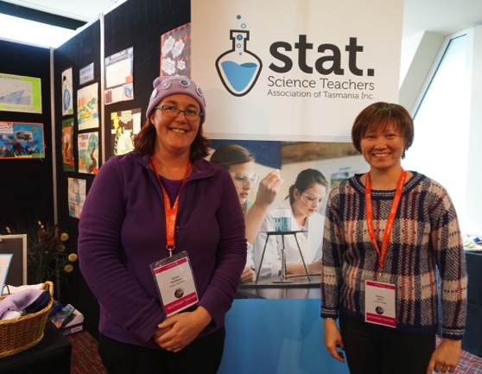By Sonya Matthews, Prospect High School.

WOW! Who knew that Hobart could be such a wonderful venue for CONASTA 66 – Art of Science? With MONA, Mt Wellington, the Casino and the University of Tasmania close by, the options were endless. I have lived in Launceston, Tasmania all my life and have travelled to Hobart a few times and when the chance arose for me to attend my first ever CONASTA in my home state, off I went.

My first impression upon arrival at CONASTA was of the vast number of attendees from all around Australia. CONASTA began with a ferry ride and a visit to MONA, how superb! What an outstanding setting and a wonderful introduction. I realised, when boarding the ferry, that this was going to be bigger and better than any conference I had attended in the past.

The workshops were immensely important to me and I obtained resources, inspiration and networked. I was able to attend a variety of offerings in the areas of Science, Maths, ICT, Engineering and Assessment. I was particularly interested in the absolutely amazing research and development occurring at the ANSTO facility in Canberra and I found the STEM topics to be most useful for my classroom planning.

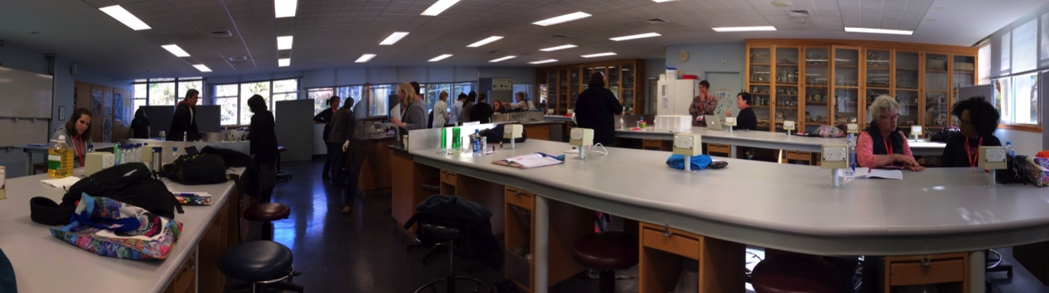

The highlights for me were the guest speakers. It was so amazing to hear from such wonderful Scientists and Educators who showed great passion and knowledge in the work that they love. Just listening to them overcoming difficult, real world problems, discussing current and very intense scientific discoveries and advancements engaged me so fully I will forever remember them. I am so grateful to have heard them and it has been wonderful to have conversations with students about recent discoveries and innovations. To tell students that I have heard the scientists in these fields discuss their findings, challenges and solutions has been valuable. While listening to the speakers I realised that there were so many things that my students and I take for granted and at this conference there were some profound examples of people, who through their dedication and love of Science, achieved excellence.

Thank you so much to STAT for providing the scholarship that allowed me to attend, and thank you to ASTA and our state convenors for organising the event.

# 2018 Science Teaching Conference in Burnie

[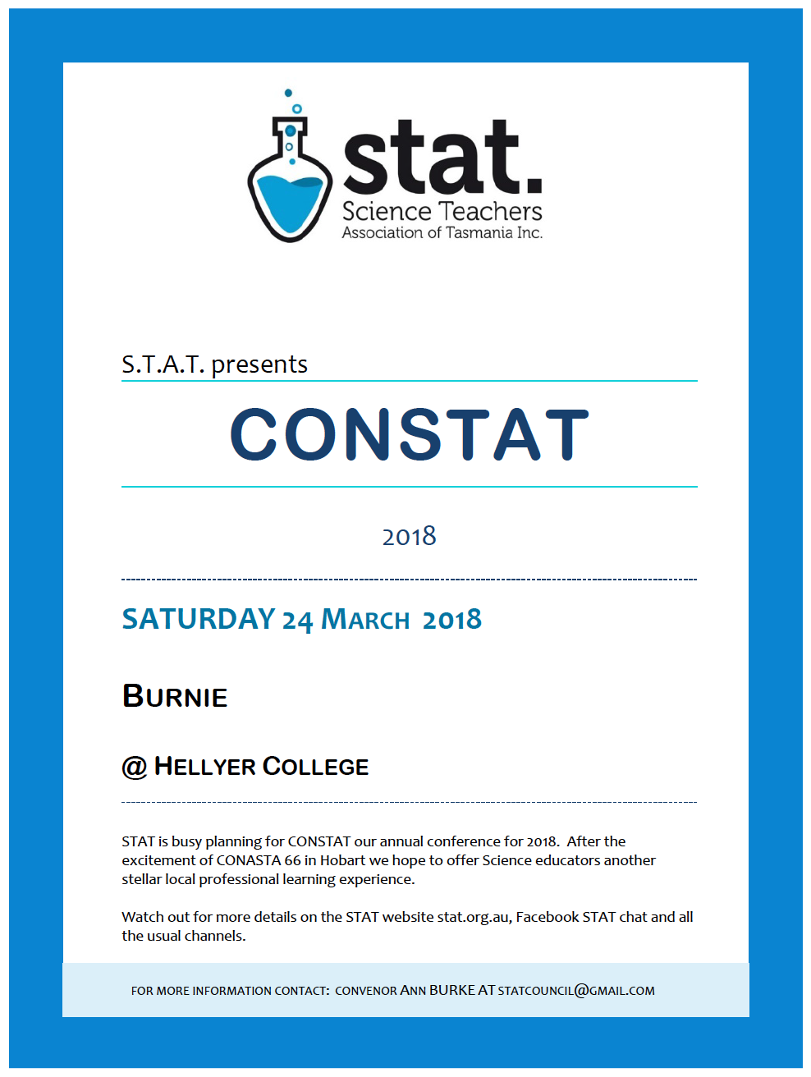](http://stat.org.au/professional-learning-2/constat-2018/)

***Watch the STAT website for details:***

[***http://stat.org.au/professional-learning-2/constat-2018/***](http://stat.org.au/professional-learning-2/constat-2018/)

# 2018 Agricultural Educators Conference in Launceston

[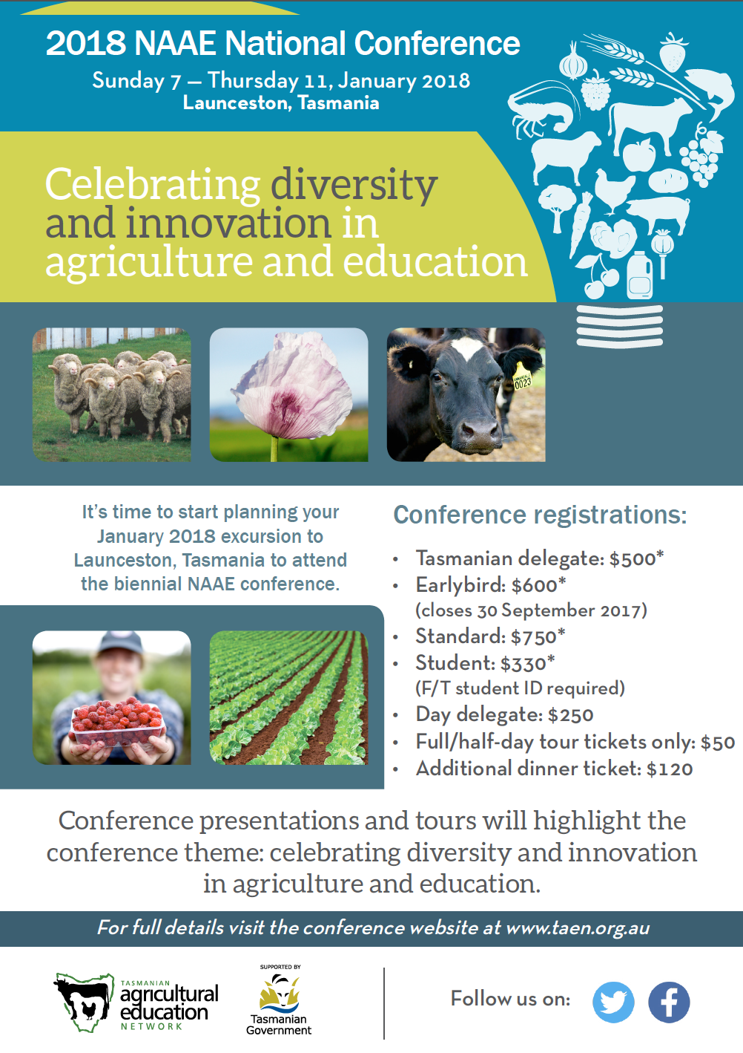](http://taen.org.au)  
***For more information visit:*** [***http://taen.org.au***](http://taen.org.au)

# Science Week – Collinsvale Primary

By Kel Innis, Principal.

During Science week the students of Collinsvale Primary School went “Mad for Science”. Every student and teacher dressed up in a Science theme and participated in four rotations of science activities which tied in with Australian Curriculum Science. At lunchtime we also held a Science fair where local community members showcased what they did in the community. We included a High School Science teacher, a Biochemist, a Botanist and an Environmental Scientist.

It was a very successful day that the students really enjoyed.

# Future Earth: Future Lauderdale Primary School

By Jess Fuller-Smith

At Lauderdale Primary School all 27 classes, Kinder to Year 6, contributed to create working models of our future, sustainable school. The models addressed some of the key challenges to global sustainability identified in Future Earth's 2025 vision, such as delivering water, energy and food.

Each year group contributed an element of the models, with that element aligned to their science or mathematics curriculum. Year 5 students created the buildings with solar powered lighting installed by Year 6 students. Prep students planted the vegetable gardens with irrigation installed by Year 4 students. Year 2 created the waste management system including working worm farms and Year 3 designed native gardens. Year 1 built playgrounds and Kinder students created people.

|  |  |  |
| --- | --- | --- |
| Macintosh HD:Users:joeekelk:Desktop:STATIC October:Lauderdale:unnamed-5.jpg | Macintosh HD:Users:joeekelk:Desktop:STATIC October:Lauderdale:unnamed-2.jpg | Macintosh HD:Users:joeekelk:Desktop:STATIC October:Lauderdale:unnamed-4.jpg |

After the project students planted the vegetable seedlings in our school garden, planted the native seedlings in a local reserve and packed up all other materials to be reused in future projects.

Thank you to the Australian Science Teachers Association and the Science Teachers Association of Tasmania for their grants. Thank you also to Acton Park Landcare, Bunnings Warehouse, Clarence City Council, Julie Collins MP, Lara Giddings MP, Vanessa Goodwin MLC, Premier Will Hodgman, Jacquie Petrusma MP and Senator Lisa Singh for their in-kind support. If you are wondering why so many politicians made in-kind donations, their old election signs were a key element of the models.

# STEM Shines at East Launceston Primary

By John Bardenhagen

On the 27-28th of September Grade 5-6 students at East Launceston Primary School ran a STEM Expo. The purpose of the Expo was to showcase ELPS’s leading practice in STEM education in Primary Schools. The STEM Expo allowed students in younger classes to view and participate in STEM activities being displayed or run by the older students.

Later that evening, the expo continued with parents and friends invited to view the STEM related activities and discuss with students the various STEM projects they had been working on and presenting.

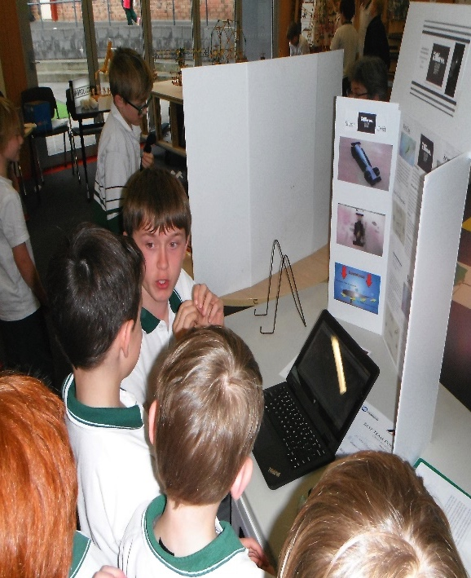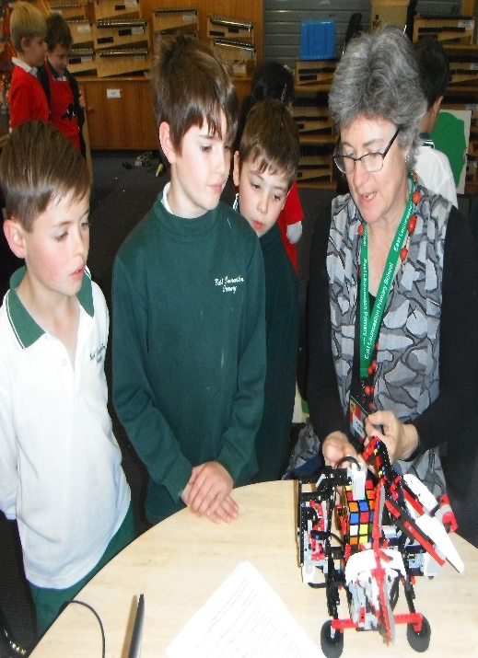

**The STEM Expo included:**

* Science and maths focused interactive activities;
* F1 in Schools car racing and CAD demonstrations;
* Science Investigation Awards entries;
* robotics, interactive electricity activities/display;
* TSTS Engineering and Technology entries;
* TSTS Digital Interactive and Photographic Essay entries;
* live 3D design and printing; and
* activities run by younger class groups.

The day was a great success and allowed students and parents to gain a greater awareness of the importance of STEM, as it is within this area that so many careers will be forged now, and in the years to come.

# Amplify STEM at Invermay Primary School

By Kristy Tidey, Invermay Primary School

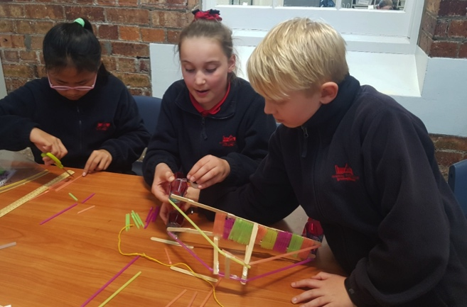At Invermay Primary School we have been working on delivering inquiry-based STEM units that are relevant to our students and involve them in designing solutions to real world problems. Our school community is built on flood plains and students have first-hand experience of the impact of floods. With this context in mind, we implemented a STEM unit that culminated with students working in collaborative teams on an engineering design challenge: Can we create a bridge structure that allows access for public transport whilst withstanding flood conditions?

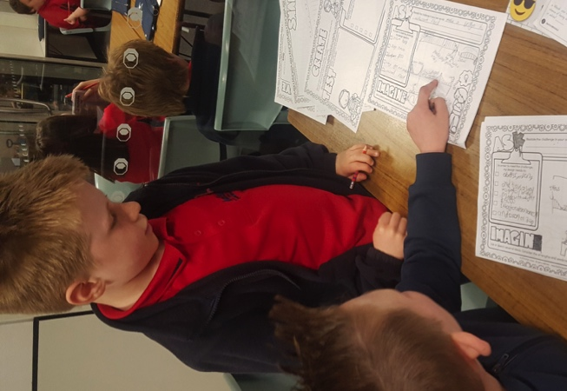Our unit began with inquiry-based learning on the environmental impact of erosion, flooding and extreme weather in the local community as well as other parts of Australia and the world. We worked in partnership with the Launceston City Council and the LCC Emergency Coordinator to deepen student’s understanding of the importance of our local government’s initiatives in the minimization of flooding risk in our Invermay area. We examined aerial photographs of flooding and compared them with Google Earth and historical aerial photos of the same area. Some key inquiry questions included, “How has the impacts of floods on human communities changed over time?’ and “What can we learn from past floods to minimise future damage? Should people be allowed to rebuild homes and other structures in areas prone to flooding?” Some students chose to present their information as a recorded news report using a green screen, others created digital brochures or google slide presentations.

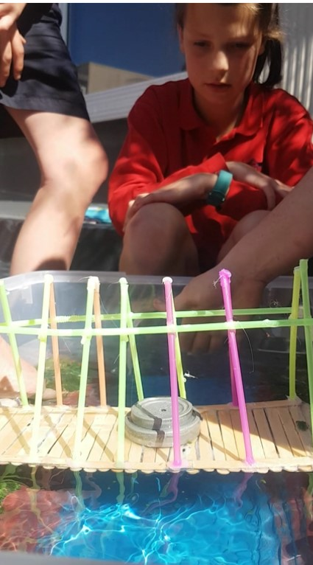We then explored why communities need bridges and investigated different bridge structures around the world. Students researched effective and ineffective bridge designs and the factors that impact on design decisions. They were then guided through the Engineer Design Process with an emphasis on team work, problem solving and creativity. Students needed to budget the cost of materials for their bridge designs and make ‘purchases’ from the ‘STEM shop’. We created a model river for students to test the strength and stability of their bridge structure in simulated flood conditions. The testing process was recorded to support students in their learning reflections.

Providing students with the chance to enhance their 21st-century skills and solve hands-on real world problems has them excited about the possibilities STEM offers. We have some students begging to keep working on their projects during lunch breaks, and other students coming up with their own ideas for problems they’d like to tackle next in STEM. Solving actual problems that are relevant to the world around them has helped students to see what it might be like to work in the STEM field and they are more engaged with those topics.

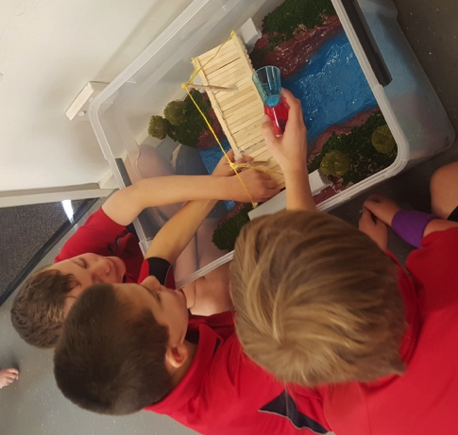

Our school is in the early stages of adopting a STEM approach and we are currently working on developing a whole-school scope and sequence with links to My Education and the General Capabilities in the Australian Curriculum. A future focus for Invermay Primary involves creating partnerships with local businesses and industry as another avenue for providing authentic and value-adding STEM experiences.

# A STEM Investigation in Kindergarten

By Emma Smyth and Georgia Fountain, Moonah Primary School

Students were observed discussing how their toy cars moved and how they rolled down a slope. The investigation took hold from there as more and more students began to wonder about what might make something roll faster or roll further. Opportunities were provided for students to explore how different sized balls rolled and moved. They explored the marble run, blocks and balls outside and a variety of loose parts. Students were introduced to digital timers to measure how quickly their ball or marble completed the course. Students were guided to think critically about how things moved by sorting and discussing different items.

|  |  |  |
| --- | --- | --- |
| C:\Users\georgia.fountain\AppData\Local\Microsoft\Windows\INetCache\Content.Word\IMG_4964.jpg | C:\Users\georgia.fountain\AppData\Local\Microsoft\Windows\INetCache\Content.Word\IMG_4958.jpg | C:\Users\georgia.fountain\Desktop\STEM\STEM Pics\IMG_2519.JPG |

Opportunities were also provided for ‘real-world’ connections, such as investigating the use of the tip tray on a utility truck. Students were inspired to create their own marble run after watching a number of Rube Goldberg videos. They worked both collaboratively and individually to create their project. Students were then provided with opportunities for reflection about their thinking processes and how their marble or ball moved.

The class are continuing to notice different types of movement and the inquiry has now moved towards how aeroplanes fly so we will be continuing our investigation this term!

# Amplify STEM at Sandy Bay Infant School

By Frances Thorp, Sandy Bay Infant School

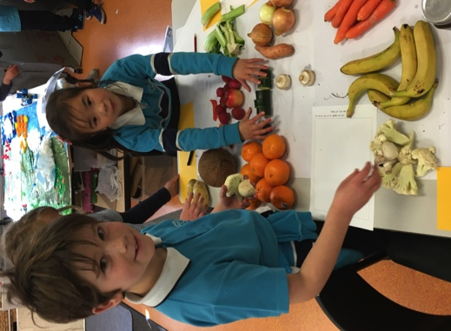Sandy Bay Infant School is a Kindergarten to Grade 2 school located in Southern Tasmania. Over the last 12 months the staff and students have been involved in developing STEM based inquiries that reflect our unique context and approaches to learning.

During Term 3 this year, the SBIS community engaged in a whole school STEM focused inquiry entitled ‘How Does the Garden Grow?”. Teachers worked together with teacher assistants and education facilitator attendants, administration staff, families and the wider community to foster our whole school STEM approach.

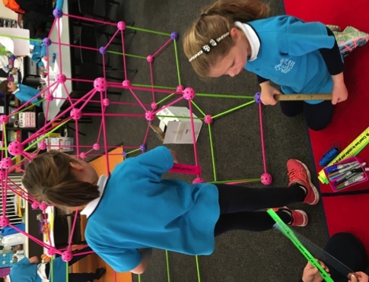The inquiry concept, ‘*The Natural world offers us opportunities to learn about life’* was pursued through authentic and meaningful learning opportunities whereby the students researched, questioned, designed, built, evaluated and assessed their experiences. A lead teacher was identified and worked collaboratively with staff to foster their understanding and expertise of the STEM curriculum areas and linking these to the Australian Curriculum and Early Years Learning Framework. Additionally, the staff developed and updated an iLearn document focussing on how we could capture student’s learning while developing their digital skills.

Perhaps one of the most memorable provocations was ‘*Staking our claim’*, with each class planting a section of our school garden, and observing it change over time. The children excitedly prepared the soil, planted and watered their plants. They delighted in the successes and pondered on the reasons why some plants didn’t grow. They set up experiments to test how different conditions affected the growth of the plants. Additionally, our front foyer became a growing exhibition of our new knowledge as each class contributed to showcasing their learning.

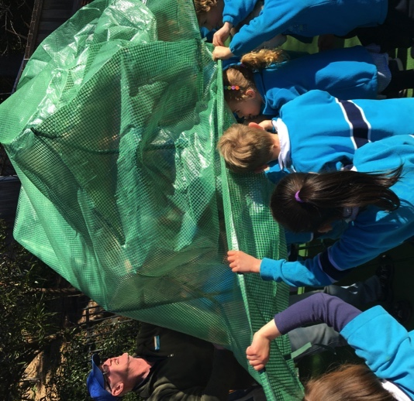

Another success was designing and building mini hot houses. The children formed conclusions about structures that could be replicated on a larger scale, and then used the ‘Crazy Fort’ sets to produce a larger scale model. They used problem solving skills to measure and fix windows to the hot house, working in teams to modify their designs. Children also designed self-watering systems which they had designed and modified to enable their plants to grow. Our Kindergarten students enjoyed many play-based learning experiences, particularly as they explored mud, created gardens and linked learning to farm life.

Working with the wider community was highly beneficial for us and included using our parent expertise and knowledge. This led to engaging staff from UTAS and visiting the hothouses there, the Botanical gardens and inviting expert guest speakers into our school to share knowledge added to our inquiry. Our experts shared about bee keeping and sustainability. Even after the Term break, children are still bringing in evidence of their learning and links to this whole school focus.

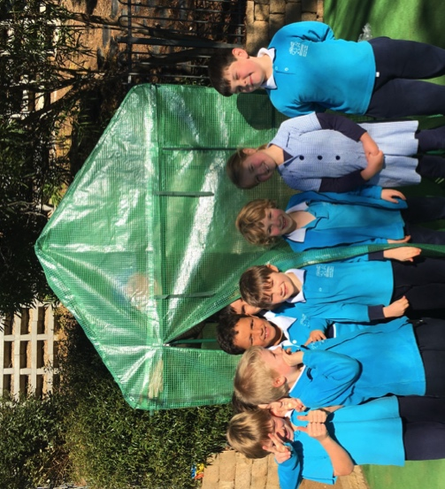

As a culmination of our inquiry and showcase of our learning, we presented a whole school musical, ‘There’s a Sunflower in my supper’ (Out of the Ark Music). The children designed and created costumes and props as part of the specialist Art program. They researched sound and lighting techniques, sand songs and rehearsed lines that reinforced the inquiry concept.

At this time, we are all looking forward to sharing a ‘Long lunch’ as we create a range of dishes from our gardening success!

# Amplify STEM at Lansdowne Primary School

By Bridget Field and Maria Pace, Amplify STEM team – Lansdowne Primary School

At Lansdowne we use an inquiry approach to teaching in all areas of our school day. We have been fortunate to have worked alongside Kath Murdoch, and this partnership is continuing into next year. An inquiry lens to our teaching not only builds upon our student’s repertoire of strategies and techniques as active, curious, connected learners, but it also fits beautifully with a STEAM approach to challenges that are real life and meaningful.

**Our message to teachers:**

* **Jump in and try it**- the children are much more capable than I think we ever give them credit for. Less teacher talking, more watching them innovate!
* **Ask for help**- there are fabulous experts around us in Tassie that are keen to assist- The Sustainability Centre is outstanding and our classes came on an excursion at the very beginning of this journey (Jenny D has been an invaluable expert for us and we can’t thank her enough)
* **Invite them in.** Share your learning with not only the parents, but community members, as not only do they love being able to see what we do, but also they may assist with grants/money and expertise! Spruik what you’re doing on the school Facebook page, really celebrate the children and their innovations!
* STEAM challenges don’t always have to rely heavily on digital technology (we love using it and it is a fantastic tool, but much of our learning prior to digitalising our designs were drawn, written, measured by hand - it needs to be an embedded tool)
* The incidental, along the way learning has been fantastic, for example, having the opportunity to ask the Minister for Energy about his feelings on plastic bags. Challenges for Tasmania has been exciting and enriching for us all.

**This was our real life challenge:**

*Australia is in the grip of an energy crisis. South Australia lost power for a day completely in 2016. Tasmania's water levels in dams were at an all time low in 2015.*

*Our challenge in the future is to come up with solutions to design alternative means of energy for use in Tasmania*.

Our Grade 6 students were asked to design, make and market a plan of a working prototype to demonstrate their understanding of renewable energy for a working STEAM installation in our school garden.

|  |  |
| --- | --- |
|  |  |

Our learning goals grew, and adapted, as our work evolved with the help of our students, however initially they were to understand:

* What is involved at each stage in the engineering design process and scientific design process
* Simple machines such as levers, pulleys, wedges, pumps, turbines, wheels, axles and screws enable work to be performed
* Technology, Scientific and Mathematical knowledge can be used to solve problems and inform personal and community decisions

Students were asked individually to design, invent and create an idea for our school garden, to demonstrate their understanding of renewable energy. The garden installation didn’t have to, but it might serve a purpose. So, for example, we had pumps that worked to water our veggie garden.

Each student created an annotated diagram that we put up around our classroom, and students provided one another with feedback about their designs. Some ideas were weird and wonderful, however providing constructive feedback to one another, not only assisted the creator of the design, it gave students additional ideas for their own plans. Student engagement and enthusiasm was high in this initial stage largely because there were no right or wrong answers. We talked about FAIL, standing for a First Attempt in Learning and that all ideas were valid, even if they may not work…

**Working in teams to create 10 designs**

We needed to lean on the Learning Assets our students required to successfully do this; we encouraged collaboration, self-management and communication. Everyone had input into designing a team installation with the best bits of the original ideas. This was a fascinating process to watch and one that worked successfully I think, because we were very explicit about how to negotiate and communicate with one another.

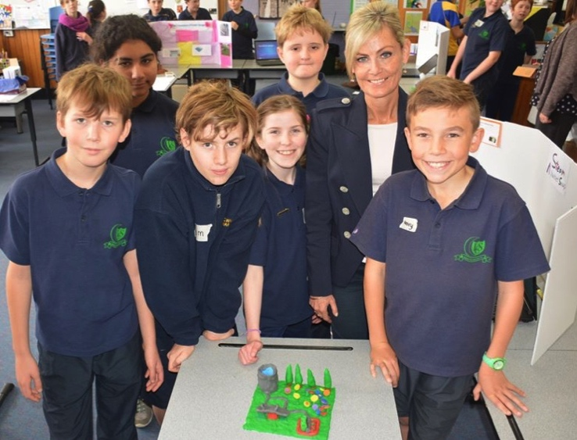**Going Further: Our STEAM Expo**

We then got our ten teams to make to scale prototypes of their designs, to market and explain their installations. The success criteria for this was created by our students, and required our students to have a model of some sort, a way of explaining their designs through use of digital technology, and a clear way of receiving feedback from others.

**Making Connections**

Their STEAM booths as we then called them, were so impressive that we decided to not only invite in other staff from around our school, but extended an invitation to our families, Curriculum Services, and then some politicians. The Education Minister The Hon Jeremy Rockliff came in, as well as Madam Speaker, Elise Archer and then Minister for Energy, The Hon Matthew Groom.

The community partnerships formed through hosting our expo were incredibly valuable as it gave our students an actual audience with whom to share their ideas and knowledge. The feedback students received was not only complimentary, but useful, as many groups had sheets asking for assistance in terms of building the installation and if any grown ups had additional engineering skills to share with us. A nice link to MyEducation and connecting to our community!

**Taking Action**

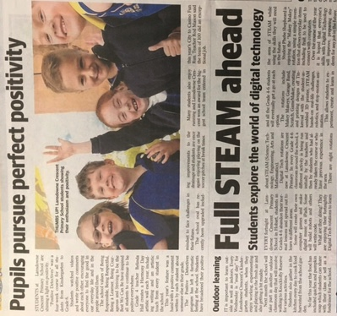So at the moment in the first week of Term 4, we are in the Taking Action stage. After inviting the politicians in, we were lucky enough to be gifted $2000 from the Premier’s Discretionary fund to assist in building one of the ten installations in our school garden.

Before we decide on which design we will build, we are going to go back to our initial designs and see if the groups want to tweak, modify and change their ideas since learning more in Term 3 about different types of renewable energy. Once we go through this phase, we aim to build one working renewable installation within the garden late this year/early into next year and will invite our 60 grade 6 students back to “open” our installation. They are very keen on a plaque with the names of the 2017 Grade 6 cohort written on it, to demonstrate their learning for years to come within our community

# ASTA Teacher Exchange to Japan

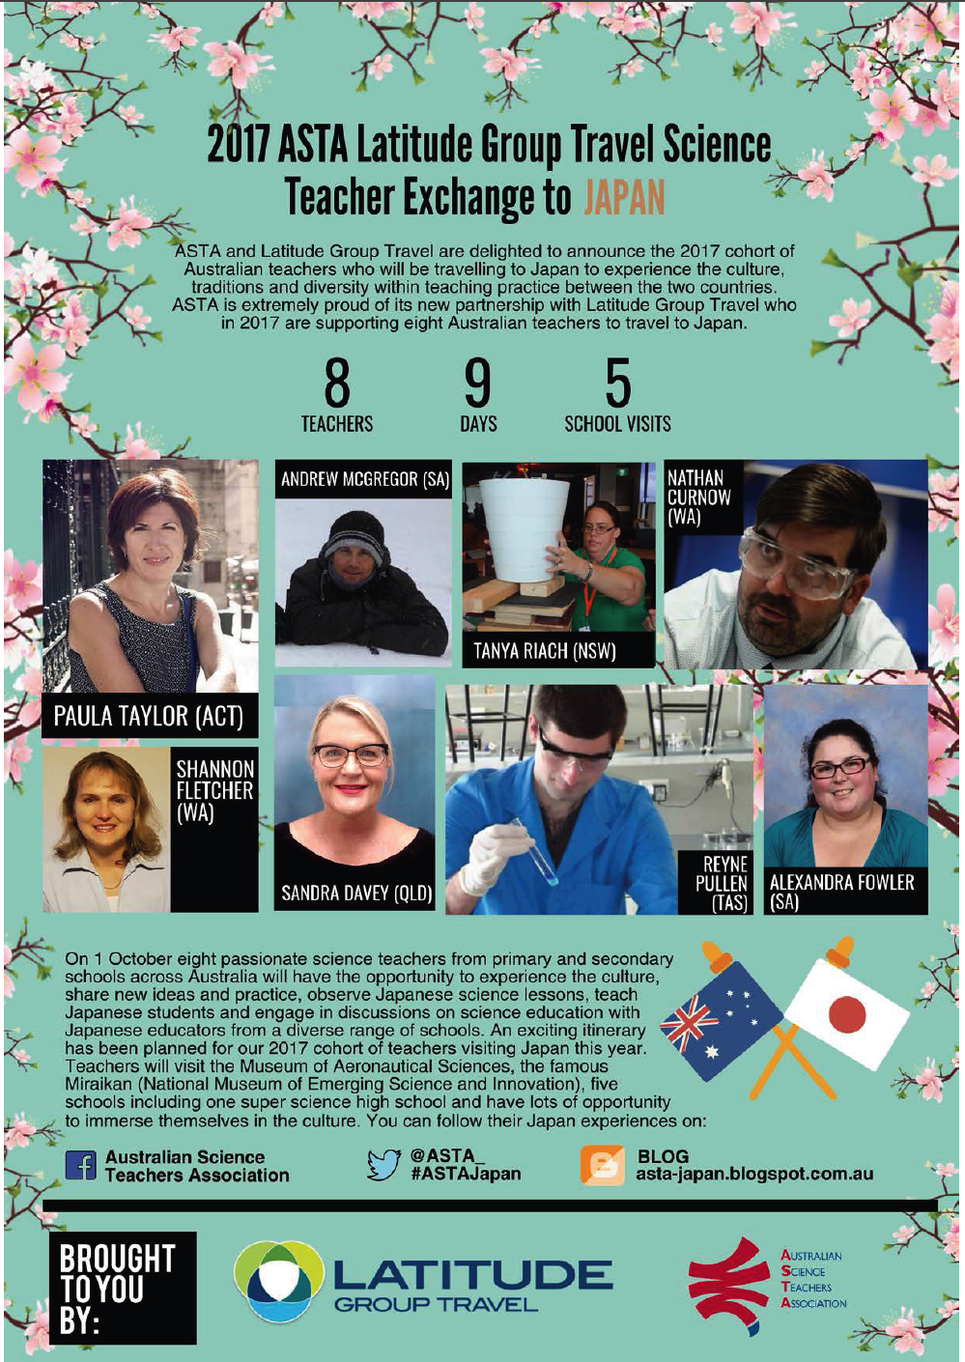

***Follow their adventures:*** [***http://asta-japan.blogspot.com.au***](http://asta-japan.blogspot.com.au)

# Teachers visit Japan to transform their STEM teaching

On 1 October, a delegation of eight Australian science teachers will travel to Japan as part of a weeklong science teachers exchange program to experience the culture, traditions and diversity within teaching practice between the two countries. The ASTA/Latitude Group Travel Science Teacher Exchange to Japan is made possible through the generous support of ASTA’ s new partner, Latitude Group Travel.

Andrew McGregor, Alexandra Fowler, Nathan Curnow, Paula Taylor, Sandra Davey, Shannon

Fletcher, Reyne Pullen and Tanya Riach are science teachers from South Australia, West Australia, New South Wales, ACT, Tasmania and Queensland who will be representing Australia to share their experience and expertise with Japanese teachers and students. They will have the opportunity to observe Japanese primary and secondary science classes and lead classes of their own (with an interpreter). The teachers will also take part in forums to exchange ideas and practices and engage in discussions on science education with Japanese educators from a diverse range of schools.

Andrew McGregor, a teacher from Yahl Primary School in South Australia is eager to share Australian culture during the exchange program through his creative lesson plan. He has designed a hands-on experiment using the iconic Australian vegemite, to conduct low voltage electricity. “I am constantly looking for ways to improve my teaching and nurture a culture of students who are passionate about their learning in STEM and I believe that this trip will greatly influence me as a 21st century educator”, he said.

Nathan Curnow, a passionate science teacher from John Curtin College of the Arts in Western Australia is also keen to share his STEM knowledge with the Japanese students and educators. “Through the Japan experiential trip, I hope to incorporate more practical engineering, design and problem-solving practices into my classroom”. As a dedicated educator who values creative science education and critical thinking, Mr. Curnow will be presenting his state-of-the-art lesson plan that allow students to design and test mechanical robot claws that could be used to perform tasks involving motor control.

An exciting itinerary has been planned for our 2017 teachers including visits to the Museum of Aeronautical Sciences, the famous Miraikan (National Museum of Emerging Science and Innovation), five schools including one super science high school as well as a myriad of cultural opportunities.

Further information and daily updates on the Japan trip can be found on Facebook and Twitter, using #ASTAJapan, as well as on our blog on <http://asta-japan.blogspot.com.au>

[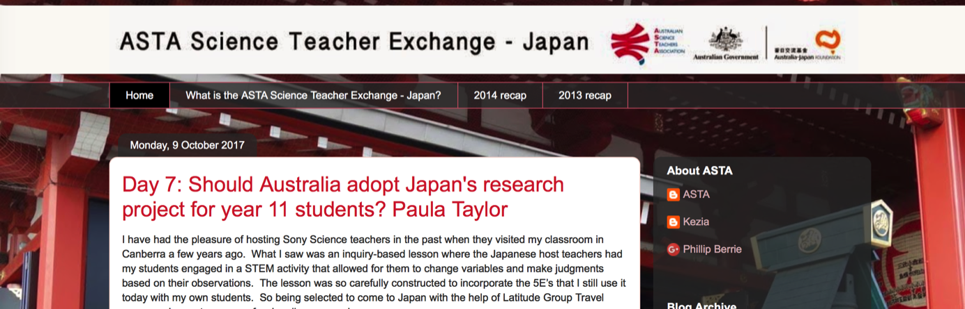](http://asta-japan.blogspot.com.au)

# The STEM X Academy: A personal account.

By Bob Fletcher, Lambert School

At three and a half years into my teaching career I felt I was building the fluency to teach with confidence but still felt that there was something missing. I had developed some engaging unit plans and built a plethora of activities that were fun. Students gave me pleasing feedback on lessons and were learning, thinking and leaving to study science at college on completion of year ten….. most of the time.

Deep down I felt I was still falling back on too many teacher-centred lessons. I was not leaving enough space for creativity, investigation and integration of new ideas. I felt I was looking back to the history of science more than looking ahead to the future. Too much understanding, not enough inquiry. I knew how I would like to teach, but lacked the time, resources, networks and confidence to try a new approach that would build the kind of curiosity in students that will be needed by future generations. We have all heard about building skills for jobs that do not currently exist for solving problems we do not yet know we have. For those familiar with Sir Ken Robinsons well –known analogy, was I teaching the girl who drew God? (Check out the TED talk if you’re not sure what this means.). Was I reaching every student?

Thus feeling the need to further my professional development, I applied to attend the second STEM X academy held in Canberra in January 2017. I had little expectation of being accepted, aware of its growing popularity and limited space. However, I was offered a place and, feeling lucky, willingly accepted.

The STEM X Academy had its inaugural year in 2016, and the second edition was run in partnership with ASTA, Questacon and CSIRO, with support from industry and government organisations. It is a five day residential program run with the epitome of enthusiasm and energy by all involved. The primary aim is not to arm the teacher with ready-made resources to take back and use, although there is plenty of that. The real benefit manifests in developing the skills, confidence and networks to develop fresh ideas that integrate hands-on activities in STEM based, challenging units of work.

‘When students are inspired to investigate and problem solve, their world becomes more meaningful, more profound and their learning more real.,’. CSIRO STEM X teacher booklet.

At CSIRO, teachers worked in small groups to pick apart techniques to formulate, refine and analyse questions, a task students sometimes find difficult to achieve. This led to developing our own investigation based upon a future challenge scenario, alongside Tarryn from the Atlas of Living Australia and Brian, a curator from the National Insect Collection. Our group, given the over-arching theme of biosecurity, chose to investigate methods to trap and identify mosquitos. This was so much more than the project itself. We were actively participating in the highs and lows, successes and failures of actual science. As we were immersed in the process, we began to think like teachers of science as well as scientists, to meld the often disparate worlds of practise and education. What emerged was a metacognitive approach to developing and structuring investigations.

Many groups felt challenged and pushed themselves outside their comfort zones to produce some inspiring and outstanding investigations. If you are reading this after staying up until 1am marking, planning and writing reports, being pushed out of your comfort zone in Canberra to work harder on refining your unit plans probably does not lend itself to great appeal. Each day I was up at 6am and worked through to 11pm, but this never felt like a working week. Interspersed between activities at CSIRO were site visits to some of the fascinating science based sites of Canberra, such as NASA’S Deep Space Centre, Mount Stromlo observatory, botanical gardens, national arboretum and Geoscience Australia. From these visits, ideas and resources were gathered from inspiring speakers active, respected and immersed in their respective science fields such as Dr Ben Greene and Dr Brad Tucker.

An evening was spent locked in after hours at Questacon, for a superb meal before being let loose to explore the curiosities, games and, as it happens, the science of freezing gin and tonics in liquid nitrogen. Questacon also engaged us in the art and science of makerspaces, thinking as low budget engineers to sculpt and form everyday objects into functioning (or otherwise), reponses to challenges.

Ultimately, the measure of any PD is how students will benefit from it. The ideas and resources have allowed the STEM X alumni the freedom to innovate. They have been inspired by authentic, contemporary research and a network of professionals, to develop programs encouraging students to be creative, pursue questions and explore. I know this because we STEMexers stick together. An active Facebook group, of which we were all a part, began developing and sharing ideas and resources, which is slowly morphing into an exclusive, yet collaborative blog. It is this continued collaboration that is perhaps one of the most valuable outcomes that allows shared innovations to quickly enter the classroom.

I have groups of year eight students investigating the question of whether we can extend the capacity of the human mind. I have another group designing an exoskeleton foot to enhance movement and support for people with injuries or a disability. Another class are building tectonic plate boundary models. My year three and four primary class have investigated the states of matter using dry ice and are currently building a bee hotel. They are encouraged to think about and develop their own lines of questioning, to be creative and think beyond the classroom, or the test, or the rote learning of knowledge. However, not every lesson I am teaching is hitting the mark. Not every idea I have tried has worked. I have had successes and failures. Not everything I do is innovative, but then this will always be inherent in teaching, as it is in science.

The main point of attending and going beyond STEM X is to be hungry for ways to get our students to think and become the discoverers, innovators and thinkers who will engineer their future.

# 2018 Festival of Bright Ideas – Date Saver

|  |  |
| --- | --- |
| Schools Day Friday 17 August.  Public Saturday 18 August.  Princes Wharf Hobart  10am-5pm.  Find out more: <http://festivalofbrightideas.com.au> |  |

# F1 in Schools: Involving your primary aged students

By John Bardenhagen

On September the 14th, two Grade 6 teams from East Launceston Primary participated in the F1 in Schools State Championship held at The Tailrace in Launceston. The entry point category for our first up participants was “Cadet Class”. This class is ideal for younger students (Grades 5-8) who have mastered the basic skills required for designing a car on CAD software such as “Autodesk” and presenting a poster to showcase features that were considered when modifying their car to make it faster.

|  |  |
| --- | --- |
| C:\Users\john.bardenhagen\AppData\Local\Microsoft\Windows\INetCache\Content.Word\F10917-1069.jpg  *Ellie Bonner and Lauren Cashman with their “Cadet Class” award winning certificates (photo provided by Rob Burnett)* | *Teams “Silver Drift” and “Dream Nation” with their cars, posters and award’s certificates.* |

The teams were required to complete eight races – four were automatic launch released and the final four were reaction racing. Both teams were also assessed on “Engineering Design” and were awarded points based on their ability to adhere to car manufacturing rules and regulations.

Apart from the STEM learning the students had already learned and applied in preparing their entry, the day itself proved to be a tremendous learning experience for our students as they were able to witness the pathways and progression required to participate in higher divisions such as “Development” and “Professional” class.

For primary school teachers wanting to truly engage their students in STEM-based learning, designing and racing an F1 car is achievable. You can use Autodesk as a CAD software and have cars milled in a high school setting, or simply have students create a homemade car using basic tools and finishing products. For running your finished cars on a track, and for any other advice related to F1 design, racing and resourcing, contact John Bardenhagen at East Launceston Primary School.

And for the record, our two teams acquitted themselves with distinction. “Dream Nation” took out the Cadet Class Championship title with “Silver Drift” runners-up, proving that primary school students are capable of competing in challenges in an environment usually reserved for older students.

# STAT Membership 2018 - Heads Up

By Jill Reade, Membership Officer

STAT has increased its membership rate by 5% for next year in-line with capitation and Teaching Science increases which come from the Australian Science Teachers Association (ASTA). STAT is a member of ASTA. We have kept our student rate low and only charge for Teaching Science journal. See the new membership form at [stat.org.au](file:///C:\Users\jillr\Downloads\stat.org.au) for the rates.

Just a reminder that invoices are sent by email (using PayPal as the generator) at the beginning of February and memberships are due for renewal on the first March. Members are welcome to renew or join any time after the new rates are up.

**Hint: Final year education students - join now and have the student rate for 2018!**

**Benefits of membership:**

* **CONASTA -** STAT members are entitled to reduced registration fees for the annual national conference, CONASTA.
* **Where to Enjoy -** STAT individual members also have access to the rewards scheme *Where to Enjoy*, (more details <http://asta.edu.au/>)
* **Publications -** Members of STAT receive the ASTA quarterly journal *Teaching Science* and access to STAT’s newsletter STATIC
* **National Science Week Booklet -** STAT members have access to the Science Week Resource Book, which provides many science project ideas on the theme.
* **Teacher Awards and Fellowships -** STAT members have access to all awards available through ASTA, including Ruth Dirks Scholarships to CONASTA, STEM X program, BHP Teacher Awards and overseas fellowships.   
  ***STAT also provides a scholarship to each years CONASTA***.
* **ASTA student competitions** - STAT members receive all information regarding the various awards that are initiated and promoted each year.

**STAT also offers:**

* **Professional development -** STAT conducts a range of professional development activities and conferences, from K – 12, covering all areas of science education. The most significant STAT activity is the annual state conference, ***CONSTAT***. STAT members are given significant discounts on all professional development activities. (ASTA also provides on-line professional development opportunities).
* **Student activities ( K- 12)**  - Members receive information (and/or discounts) on all student activities that STAT is involved in.
* **The Tasmanian Science Talent Search (TSTS)** - open to all students from K to Year 12. It aims to broaden awareness of, and interest in, science throughout the community. Many students from all sectors participate in TSTS annually, with a large proportion winning awards. Winners from the TSTS Research Investigations, Engineering sections are invited to submit to the national BHP Science awards.

STAT and ASTA provide Distinguished Service Awards for members who give exemplary service to these organisations. STAT also acknowledges excellence in teaching Science at any level by presenting the Winifred Curtis medal.

# Open Letter on Copyright

Teacher Associations representing more than 200,000 teachers and/or schools around the country have signed the following Open Letter to oppose the Productivity Commission’s recommendations on copyright in Australia because it will affect their ability to create high quality resources for teachers.   
  
We the undersigned unanimously reject the Productivity Commission’s Recommendations on copyright in Australia. The recommendations to change copyright protections threaten an easy-to-use, effective copyright licensing system that allows teachers to access enormous amounts of content so they can focus on the task of enhancing the potential of students and creating lifelong learners.

It will also impact on the current fair payments that are made to creators for the use of their copyright material, many of whom are educators. These payments help fuel the creation of world-leading Australian teaching resources, many of which are successfully exported.

Australian educators, publishers, teachers, authors and creators have a right to receive fair payment for their work. The changes to Australian copyright laws being pushed by the Productivity Commission, large organisations and big technology companies will greatly diminish these protections.

This is not just unfair, it is a threat to the overall quality of Australian education and its relevance for student and societal needs and means it may be even harder to make a living for the next generation of creators of Australian educational and creative content.

The importance of copyright in supporting effective learning and in the development of cutting-edge educational content cannot be underestimated. Australian children should be able to grow up inspired and entertained not only by our local stories and our local culture, but also by locally-produced educational materials.

At a time when jurisdictions around the world are reviewing the impact of major technology companies on cultural and educational production, we call on the Australian Government and parliament to protect Australian stories and content and rule out the Productivity’s Commissions proposed changes.

ASTA is one of the teacher association signatories – full list here: <https://www.copyright.com.au/2017/08/open-letter-24-teacher-associations/>

# Tasmanian Science Talent Search in 2017

By (Dr) Marj Colvill, Director TSTS 2017

Once again, STAT will be holding the presentation of Student and Teacher Awards at the 2017 Tasmanian Science Talent Search Awards Day. This year, Launceston is the venue and over 250 students and their families will be invited to celebrate their success in Science across the areas of creativity, communication, information technology, technology, engineering and research. STAT is looking forward to celebrating student efforts and sharing this occasion with families, sponsors and of course, members. Students who receive encouragement awards have their awards presented at school.

The information booklet for 2018 will be available by the end of November and we hope to launch this at the 2017 presentation of awards. This year there are 10 new schools involved which is really exciting. Sponsorship from Rowe Scientific is specifically targeting students in years 7 – 12 and provides some exciting possibilities for students so, if your students have not had this opportunity before, consider taking it on board for 2018.

Below is the information regarding the winning students. Those students in years 5 to 12 who have been extremely successful have been invited to present their work at the BHP Billiton Science and Engineering Awards in Melbourne. This is a National event, where 26 finalists from years 7 to 12 are chosen and of these 26, 6 students are invited to travel to the Intel Science Fair in the USA. Tasmania has a long track record of success at this level and we wish our 2017 students every success, knowing that just to be invited is worthy recognition of their efforts.

# TSTS Results -Engineering and Research Investigations

***Open Engineering Section***

***Division: Upper Primary***

|  |  |  |  |
| --- | --- | --- | --- |
| **Award** | **Name/s** | **School** | **Teacher** |
| **First Prize** | Luke Woodfield | Launceston Church Grammar (JS) | Timothy Brown |
| **Second Prize** | Jack Williams & Oliver Brill | East Launceston Primary School | Darrin Timms |
| **Third Prize** | Sienna Long & Siena Urbano-Bunton | East Launceston Primary School | Darrin Timms |
| **Merit Awards** | Ellie Bonner & Lauren Cashman | East Launceston Primary School | John Bardenhagen |
|  | Luke Vandenberg & Fletcher Alps | East Launceston Primary School | Darrin Timms |
|  | Evie Leslie | East Launceston Primary School | Tamika Green |
| **Encouragement Awards** | Seth Glock & Samuel Jeffrey | East Launceston Primary School | Darrin Timms |
|  | Samuel Huett & Mojtaba Ahmadi | East Launceston Primary School | Darrin Timms |
|  | Madeline Brown | East Launceston Primary School | Jessica Crawford |

***Division: Intermediate***

|  |  |  |  |
| --- | --- | --- | --- |
| **Award** | **Name/s** | **School** | **Teacher** |
| **First Prize** | Lachlan Stedman & William Ayers | Launceston Church Grammar School (Snr) | Greg Titmuss |
| **Second Prize** | Issy Preece & Nicola Scott | Launceston Church Grammar School (Snr) | Greg Titmuss |

***Research Investigations***

***Division: Early Childhood***

|  |  |  |  |
| --- | --- | --- | --- |
| **Place** | **Name** | **School** | **Teacher** |
| **First** | Kinder, Prep & Year 1 | Bracknell Primary | Jessica Phair |

***Division: Lower Primary***

|  |  |  |  |
| --- | --- | --- | --- |
| **Place** | **Name** | **School** | **Teacher** |
| **First Place** | Taya Munday | Burnie Primary | Rebecca Gould |
| **Second Place** | Amity Blyth | Burnie Primary | Rebecca Gould |
| **Third Place** | Melaiyne Harding | Burnie Primary | Rebecca Gould |
| **Merit Awards** | Imogen Lloyd | Burnie Primary | Rebecca Gould |
|  | Lottee Rolls | Burnie Primary | Gordon Brown |
| **Encouragement Awards** | Rhiannon Milles | Burnie Primary | Susan Woodward |
|  | Darriq Ramaish | Burnie Primary | Susan Woodward |

***Division: Upper Primary***

|  |  |  |  |
| --- | --- | --- | --- |
| **Place** | **Name** | **School** | **Teacher** |
| **First Place** | Amelia Reynolds | East Launceston Primary | John Bardenhagen |
| **Equal Second Place** | Charlotte Ball | East Launceston Primary | John Bardenhagen |
|  | Charlotte Pilsbury-Milne | Launceston Church Grammar Junior School | Timothy Brown & Douglas Grubert |
|  | Mary Bradfield | Launceston Church Grammar Junior School | Timothy Brown |
| **Equal Third Place** | Hayden van der Ploeg | Stella Maris, Burnie | Daniel House |
|  | Reuben Allen | Allen Home School | Sharon Allen |
| **Merit Awards** | James Hyde | Launceston Church Grammar Junior School | Timothy Brown & Douglas Grubert |
|  | Isaac Foster | East Launceston Primary | Jessica Crawford |
|  | Oliver Stebbeings | East Launceston Primary | John Bardenhagen |
|  | Allahnah Carr & Adele Roberts | Bracknell Primary School | Lauren Ridge |
|  | Charlotte Hansson, Neve Quinn & Molly Ferguson | Margate Primary | Jan Osterloh |
|  | Tallirah Gale | Forth Primary | Daniel French |
|  | Arie Schoenmaker | Riverside Primary | Shenoa Blanchard |
|  | Laura Winchcombe | Burnie Primary | Tameika Munday |
|  | Cooper Pilgrim, Maguiar Burns & James Fletcher | Burnie Primary | Clair Jones |
|  | Sophie Strong | Newtown Primary | Di Smith |
|  | Stella Ziegler | Newtown Primary | Di Smith |
|  | Maisie Howard | East Launceston Primary | John Bardenhagen |
|  | Summer Cherdron | Bracknell Primary | Lauren Ridge |

|  |  |  |  |
| --- | --- | --- | --- |
| **Encouragement Awards** | Erin Anthony | East Launceston Primary | John Bardenhagen |
|  | Faezeh Ashouri | East Launceston Primary | John Bardenhagen |
|  | Thomas Howell | Riverside Primary | Jane Jones |
|  | Jayde Van Noord & Caitlin Smith | Summerdale Primary | Andrea James |
|  | Locie Milner & Ryan Heazlewood | Summerdale Primary | Andrea James |
|  | Millie Ferguson, Lilly Townsend & Aviva Ross | Burnie Primary | Clair Jones |
|  | Aiden Gibson | Riverside Primary | Jane Jones |
|  | Piper docking & Tannah Fraser | Burnie Primary | Meaghan Hosking |
|  | Amy Taylor | Westbury Primary | Michael Trotman |
|  | Orland Arrieta-Shadbolt & Alexander Lions | Perth Primary | Karen Dick |
|  | Kayla Hughes-Roberts & Liana Connie | Perth Primary | Karen Dick |
|  | Zoe Drane | Stella Maris | Daniel House |
|  | Mishca Linden | Table Cape Primary | Michael van der Ploeg |

***Division: Junior Secondary***

|  |  |  |  |
| --- | --- | --- | --- |
| **Place** | **Name** | **School** | **Teacher** |
| **First Place** | Emma Spurr | Kingston High | Alex Edwards |
| **Second Place** | Serena Jarmain | Burnie High | Rob Lee |
| **Equal Third Place** | Chelsey Marshall | Wynyard High | Heather Russell |
|  | Freya Cooper | Deloraine High | Carolyn Abraham |
| **Merit Awards** | Tim Shen & Stanley Drake | Hutchins School | Michaela Guest |
|  | Conner Hodgetts | Burnie High | Josh Salter |
|  | Maya Ferguson | Burnie High | Josh Salter |
|  | Lily Hansson | Kingston High | Robyn Aitken |
|  | Olivia Graham, Lucy Wolfe & Bianca Hoggett | St Mary’s College | Karen Walter |
| **Encouragement Awards** | Oliver Hugo, Samuel Fenny & Jess Wright-Burbury | Hutchins School | Michaela Guest |
|  | Harrison Lines | Flinders Island DHS | Helen Carnell |
|  | Stella Roberts & Oakie Barrett | Marist Regional College | Ann Burke |
|  | Antonia Brancher | St Michael’s Collegiate | Courtney Blyth |
|  | Sebastian Fry | Hutchins School | Michaela Guest |
|  | Jack Dixon & Oscar Dickson | Hutchins School | Michaela Guest |
|  | Meg Pinelli, Ellie Woodward & Samantha Tomes Park | St Mary’s College | Tanaz Jungalwalla |
|  | Zoe Brown & Emily Sheen | St Mary’s College | Tanaz Jungalwalla |
|  | Harry Hamilton & Rhys Kirkland | Burnie High | Sam Wells |
|  | Isabella Cox & Emily Keane | St Mary’s College | Karen Walter |

***Division: Intermediate***

|  |  |  |  |
| --- | --- | --- | --- |
| **Place** | **Name** | **School** | **Teacher** |
| **First Place** | Eloise Deconinck | St Mary’s College | Heather Omant |
| **Equal Second Place** | Saakshi Dhakal | St Mary’s College | Heather Omant |
|  | Spriha Paudel & Keeley Hine-Haycock | St Mary’s College | Heather Omant |
| **Third Place** | Chloe Cooper | St Mary’s College | Heather Omant |
| **Merit Awards** | Connor van der Ploeg | Marist Regional College | Ann Burke |
|  | Ben Saint-John | Marist Regional College | Ann Burke |
|  | Tom Reid | Hutchins School | Peter Crofts |
|  | Charlotte Bell & Peta Antypas | Scotch Oakburn College | Kate Gard |
|  | Bellamy Paine | Marist Regional College | Ann Burke |
|  |  |  |  |
|  | McKinley Nolan | Burnie High | Kim Anderson |
|  | Alana Bellette | St Mary’s College | Heather Omant |
| **Encouragement Awards** | Evan Ling | Burnie High | Kim Anderson |
|  | India Stammers | Burnie High | Kim Anderson |
|  | Andrew James, Liam Morrison & David James | Launceston Christian School | Janette Boyle |
|  | Amber Matthewson | Flinders Island DHS | Helen Carnell |
|  | Luke Bennell, Nathan Williamson & Jordan Scolyer | Ulverstone High School | Maria Chan & Peter Snare |
|  | Toni Hall | Penguin High | Sheila Sherriff |
|  | Ruby Croft | St Aloysius College | Ann Boyle |
|  | Georgia Kitic | Wynyard High | Heather Russell |
|  | Sarah Hope & Morgan Wye | Launceston Church Grammar School | Greg Titmuss |

***Division: Senior Secondary***

|  |  |  |  |
| --- | --- | --- | --- |
| **Place** | **Name** | **School** | **Teacher** |
| **First Place** | Logan Howell | Don College | Marcel Brown |
| **Second Place** | Caitlin Roberts | The Friends School | Brenda Winning |
| **Equal Third Place** | Lauren Wild | Hellyer College | Perviz Marker |
|  | Jack Butler | Marist Regional College | Ann Burke |
| **Merit Awards** | Thomas Guinan | The Friends School | Brenda Winning |
|  | Senudi Wijewardena | Marist Regional College | Ann Burke |
|  | Ginger Rankin | Hellyer College | Perviz Marker |
|  | Marlee Wells | Elizabeth College | Marty Goss |
|  | Zara Bacon & Daisy Boardman | Elizabeth College | Marty Goss |
| **Encouragement Awards** | Beau White | Hellyer College | Perviz Marker |
|  | Josie de Boer | Don College | Marcel Brown |
|  | Nicole Bryan | Hellyer College | Perviz Marker |
|  | Micah Snare | Hellyer College | Perviz Marker |
|  | Hannah Watkinson | Hellyer College | Perviz Marker |
|  | Fergus Crawford | Hellyer College | Perviz Marker |
|  | Ellie Hayton, Leyton Isaac & Natasha Winter | New Norfolk High School | Silvia Escobar |

***Key: Students whose names are colour coded have been invited to submit their entries in the BHP Billiton National Science and Engineering awards.***

As you can see there are many entries across the division and sections although it is also apparent that some sections attract much higher interest than others. If you would like support in your school to engage with an area which is new to you or to your students then contact the Director of the Tasmanian Science Talent Search. There are fantastic opportunities in Engineering and Technology and STAT is in a position to provide some professional learning in these areas.

Watch the Web Site [www.stat.org.au/tsts](http://www.stat.org.au/tsts) for details of the 2018 competition and make the most of any information which is made available there. The Science Teachers Associations across the country are prepared to share samples of student work and there will be further opportunities in 2018.

Many thanks to all those teachers, parents, and mentors who supported our students with their efforts in 2017. It will be wonderful to reward these efforts at the end of year presentation and STAT looks forward to an even bigger and better year in 2018.