STATIC
The Newsletter of the Science Teachers Association of Tasmania.

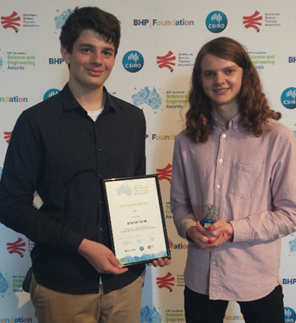

March 2019, Volume 1
STAT on social media.

STAT Council Members
President & ASTA Council Representative  Rosemary Anderson  Department of Education  Curriculum Services, Hobart | STATcouncil@gmail.com  STAT  PO BOX 1112  Sandy Bay TAS 7006
Vice President & ASTA Council Representative  Jenny Dudgeon  Sustainability Learning Centre, Hobart College, Mt Nelson | Membership Officer  Jill Reade  Science Education  College of Arts, Law and Education (CALE)  University of Tasmania, Launceston
Secretary  PL & TSTS Committee Chair  John Bardenhagen  Hagley School | Treasurer  Sonya Matthews  Prospect High School, Launceston
TSTS Co-ordinator  Doug Grubert  Science Consultant | Awards Officer  Ann Burke  Marist Regional College, Burnie
Digital Communications  & National Science Week Contact  Denise Devitt  Hobart | University of Tasmania College of Science and Engineering Representative  Jeannie-Marie LeRoi  University of Tasmania, Hobart
STATIC Editor  Bob Fletcher  Lambert School, Hobart | General Councillor  Heather Marshall  St Marys District School
General Councillor  Associate Professor Sharon Fraser  Science Education  College of Arts, Law and Education (CALE)  University of Tasmania, Launceston | General Councillor  Amanda Hughes  St Marys District School (Currently on Leave)
STATIC Editor email
editorstatic@gmail.com

Contents

STAT Council Members 2
The student response to climate change 4
bhp foundation student awards: awear 5
stem x academy 2019 7
youth climate leaders' conference 10
science and engineering challenge_________________________________________________________12
case space school__________________________________________________________________________________13
where? where? wedgie!_________________________________________________________________________19
SCIENTIFIC SNIPPETS AND DISCOVERIES 20
STATIC SCIENCE QUIZ 24

From the Editor…
The Student Response to Climate Change
Across all State capitals and over 20 regional centres, students have left schools to protest against the government policies towards climate change. There are many who feel deeply let down by the response to climate change, greenhouse gas emissions and mitigation policies. There are also many who feel confused by the issues, or simply ‘don’t believe in it’. Either way, science teaching has an important role to play in informing our policy-makers of the future in the findings of present research and the role science needs to play in decision-making. It is an area of science covering multiple disciplines, including many areas related to the curriculum such as chemistry and Earth science. It is also ripe with possibilities for inquiry-based learning and an area students’ find engaging, relevant and a rich stimulus for STEM activities.
On the 25th February, Prime Minister Scott Morrison announced a 3.5 billion dollar ‘Climate Solutions Package’. Much of this is aimed at paying agriculture and industry to reduce carbon emissions. Several emissions reduction policies have been abandoned over the last six years and in November 2018, a United Nations report found Australia was falling short in reaching 2030 emissions targets set in the 2015 Paris agreement. This target is set at a 26-28% reduction compared to 2005 emissions. Meanwhile, the science community has communicated a need to steer away from carbon-based energy sources towards renewable energy production and feels this has not been emphasised enough.
On the 15th March this year, in over 100 countries, students led 1,700 strikes, highlighting the degree of international concern. Australia is certainly not alone in falling short of the expectations of young people in the response to climate change issues. Globally it seems, politics and science seem to be at odds and scientists have generally backed the student actions.
“The idea of a climate strike is innovative. It’s provocative, and I think it’s the right form of non-violent civil disobedience,” - Gail Whiteman, social scientist at Lancaster University, UK.
Science education has an important role to play, not in taking sides, but allowing students to investigate the evidence and make informed decisions themselves. It is a topic with local and global relevance, covering sea levels, bushfires, agriculture, energy production and much more. Responses require the analysis of data, engineering innovative adaptation and mitigation solutions and an accurate interpretation of climate science. With the backing of scientific evidence, students can lead a convincing argument towards shaping their future.
In this issue of Static, we hear from IPCC scientist, John Church, who puts forward pertinent views on climate issues. We are also able to celebrate the success of students Isaac Brain and Mitch Torok, who demonstrate the level of engineering and scientific talent Tasmania is harbouring for the future. They are featured on this issues front cover, standing as a reminder for teachers as to where they may guide their students through channels of innovation like the ‘Tasmanian Science Talent Search’.
From TSTS to Arizona through the BHP Foundation Student Awards.
Tasmanian Students win National Engineering Award with “aWear”
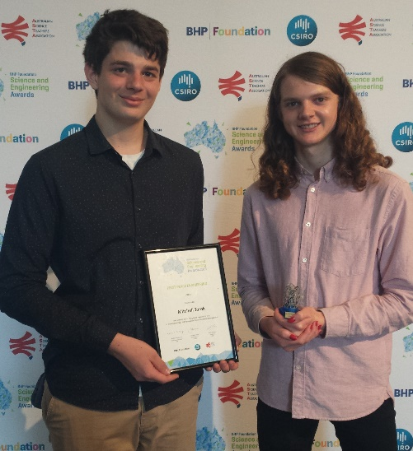

Young Tasmanian Engineers, Isaac Brain from Launceston College, and Mitch Torok from Rosny College are off to the International Science and Engineering Fair (ISEF) in Arizona, where they will showcase their winning entry in the Engineering section of the National Science and Engineering BHP Foundation, Student Awards. These talented cousins will each enjoy a fully funded trip to ISEF and will share the first prize of $4,000. They received their award at a gala dinner in Melbourne on Tuesday February 4th. Dr Larry Marshall, CSIRO Chief Executive, presented the prize and applauded their collaboration.
Prompted by a concern for their Great Grandmother and the need to care for her should she fall, together they developed a watch, aWear, which can also be warn as either a broach or a lanyard, alerts by SMS, nursing staff with both status and location of the wearer and is triggered through an accelerometer to analyse fall detection. Isaac developed the software and web development and Mitch built the hardware.
Isaac and Mitch were invited to enter the National Awards, after winning the Senior Engineering prize in the 2018 Tasmanian Science Talent Search. There were over 12,000 entries in Research and Engineering from across the country and Tasmania was represented by four students in the 26 finalists. Congratulations also go to Lucy Eade from St Mary’s College, Hobart and Emma Spurr from Kingston High school. Entries in the National Awards are by invitation only, through the Tasmanian Science Talent Search.
For complete information about the 2019 BHP Billiton finalists and to look at their videos go to https://scienceawards.org.au/Student-Awards

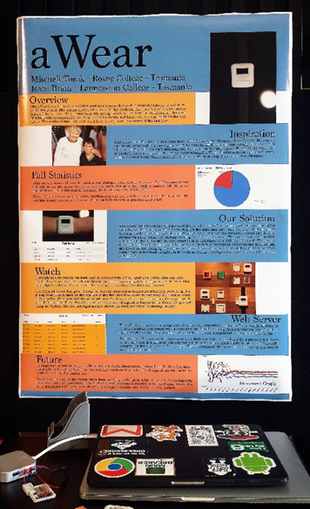

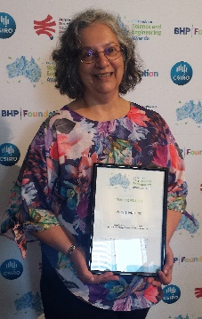
Tasmania was also represented in the BHP Foundation Teacher Awards by Dr Perviz Marker of Hellyer College. Perviz has given the last 25 years to teaching year 11 and 12 environmental science students, many of whom have experienced success in the Tasmanian Science Talent Search Research Investigation section. Her support of students to explore exciting ideas, to build on their interests and to excel in communicating important science to the wider community demonstrates a serious commitment to quality science education and Tasmanian students are the richer for this support. Perviz demonstrates this in her own research which involves penguins.

STEM X ACADEMY 2019
A Reflection by Christine Johns, Teacher at Hagley Farm Visitor Centre

In January this year, I was fortunate to be able to attend the STEM X ACADEMY in Canberra. This professional learning immersed me, and 69 others in STEM for a week and provided valuable information and time to learn and be inspired for the year ahead. Along with other STEM teachers from across Australia I was introduced to a series of amazing presenters and was able to work in groups to problem solve and explore STEM skills in depth.
Our hands-on time was largely spent at Questacon and CSIRO.
Questacon included an amazing Makerspace in which we were challenged and inspired to use STEM in our classrooms. Disassembling and reassembling a biro was a simple and fun way to stimulate us at the beginning of the day. The process of protostorming took away some of my preconceived ideas around working in STEM. To work quickly and produce quantity over quality, dispelled inhibitions and my lightbulb moment was understanding that ‘science is a process not a product’. While I had some concept of this, the activities at Questacon developed the confidence to make this work in the classroom setting.
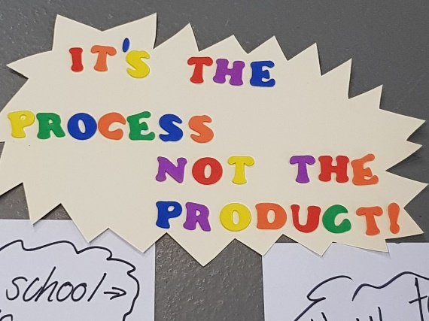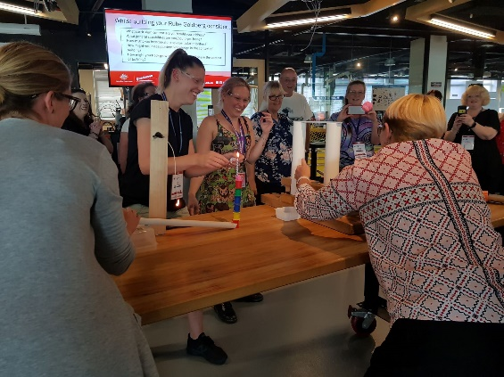

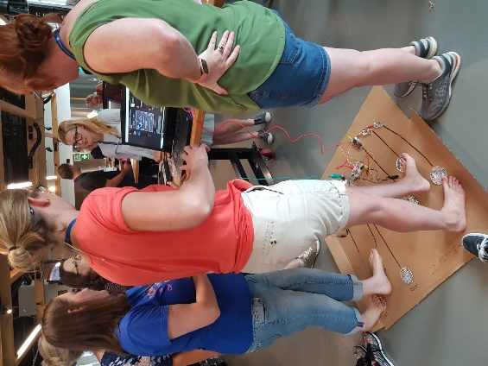
Materials dissection and the making of a Rube Goldberg Machine were further activities that expanded this concept. The Rube Goldberg Machine involved participants working in teams to create sections which would combine and allow a marble to be released at one end and move through the sections until it reached the end. This process required design thinking. Groups had to empathize, define the problem, ideate, build a prototype and test their design. This process, apart from being lots of fun, built teamwork and required careful thinking and design to achieve a goal. This was great inspiration for using STEM in the classroom. Our use of Makey Makey to create an interface was interesting and entertaining with both musical and physical applications.

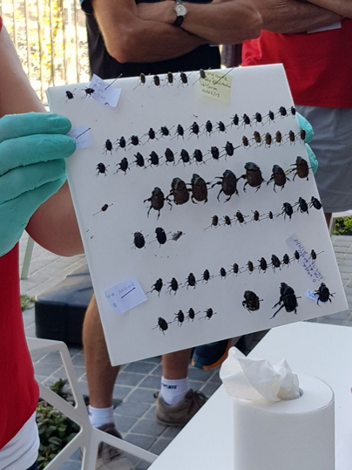
CSIRO provided us with expert help to work in groups in order to design solutions to solve real world problems. Our project-based learning was focussed on food biosecurity and in particular design solutions to solve the vorroa mite problem in bees. Working through this process gave us insight into the processes we would expect our students to follow. Tours of CSIRO and interaction with their scientists was another inspiring part of our program.

ANU Engineering Faculty workshops provided more learning and inspiration and speakers such as Dr Ben Greene (Space Environment Management) created an awareness of space junk and the issues which exist in space. Visiting Mount Stromlo and having the opportunity to interact with Dr Brad Tucker was amazing. This passionate scientist gave a great insight into space and the scientific work conducted in this area. We were able to design experiments to go into space by balloon. Unfortunately, the weather prevented our balloon launch, but we have since seen the results of ‘seeds in space’ and other interesting experiments.
The opportunity to attend this conference and be both challenged and inspired is something I am most grateful for. It has been a great way to start the school year with the ideas and inspiration gained at STEM X ACADEMY informing my teaching practice and program both now and in the future. Many thanks to the people who made this time possible.
Christine Johns (Hagley Farm Visitor Centre)

Youth Climate Leaders’ Conference
A Synopsis of the Presentation by John Church
7 March 2019

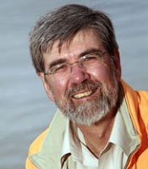

The following is an overview of the work of John Church with the Intergovernmental Panel on Climate Change.

Science tells us Climate change is one of the most important, challenging and urgent issues facing society today and will be for coming decades and most likely centuries.

So How does Science impact Policy to safeguard our common future?

Critically important is the strong communication of the science to policy makers by the Intergovernmental Panel on Climate Change (IPCC). The IPCC does not do science but through a rigorous and painstaking process formulates assessments on what we currently know about climate change, what are the future projections, what is possible, and what remains uncertain.

What is IPCC?

The IPCC is an Intergovernmental Panel of 195 Governments. They appoint a small Secretariat which, with the help of about 200 scientists, produces a potential outline of each new assessment, which then has to be approved by the Panel. The Panel then appoints an international spectrum of scientists to produce the assessments – usually four volumes: on the science of climate change, on impacts and adaptation, on mitigation, and finally a synthesis report. Each of these are extensively reviewed by scientists and governments around the world – 55 thousand comments for Volume 1 of the last assessment.

Each volume has a summary for policy makers (SPM) which is reviewed on a line-by-line basis by governments in a plenary meeting. The governments cannot change the scientific results, but if agreement cannot be reached on wording, material may be deleted.

Critically important is the overwhelming consensus in the scientific community supporting the IPCC conclusions.

Three key findings from the 2013 IPCC Assessment are:
- Firstly, warming of the climate system is unequivocal. Many of the observed changes since the 1950s are unprecedented over recent millennia. These include increases in greenhouse gas concentrations, warming of the Earth’s surface, loss of snow and ice cover, warming of the oceans, loss of mass from glaciers and ice sheets, rising sea levels and impacts on the natural and built environment.
- Secondly, human interference on the climate system is clear. It is extremely likely that human influence was responsible for the majority of the warming, and other changes, since the 1950s.
- Thirdly, limiting climate change requires urgent, significant and sustained reduction of greenhouse gas emissions.

The IPCC Assessments underpin the UN Framework Convention on Climate Change, the process of formulating policy in response to the science. As you know, progress under this agreement has been painstakingly slow. The 2015 Paris agreement was a vital step forward, committing all nations to preventing dangerous climate change by limiting warming to well below 2°C above pre-industrial levels, with a target of 1.5°C.

The recent IPCC Special Report on 1.5C of warming has reinforced the previous conclusions and highlighted the urgency for action if we are to reach the Paris goals.

So Today, we face a choice.

Unmitigated emissions will result in:
A global average warming of about 4°C by 2100, more intense heat waves and consequences for human health.
More intense and frequent droughts and floods.
The Arctic will become essentially ice free in summer and there will be a major loss of snow cover.

In my own area of research, unabated emissions mean glaciers will retreat, oceans will warm, and sea level will rise by up to the order of a metre (or several tenths of a metre more) by 2100, and many metres over coming centuries. Unabated emissions mean that this century we will cross the threshold leading to the long-term and essentially irreversible loss of the Greenland ice sheet, contributing about 7 m to sea-level rise. There may be an even larger long-term contribution from Antarctica. The question is not if there will be large sea level rise, but rather how quickly it will occur!

It is clear, unabated emissions will wreak havoc on the lives of many hundreds of millions of people – our children, and subsequent generations. There will be devastating, and in many cases irreversible, consequences for food and water security, human health and the natural environment.
In our region of the world, tens to hundreds of millions of people will be displaced by rising sea levels this century. There will be emergencies much larger than the current refugee crises.

Climate change is already having major impacts in Australia.
- Warming temperatures are bleaching the Great Barrier Reef. If we do not get emissions under control, we will lose the GBR as we know it.
- Rising temperatures are increasing the frequency of heat waves, affecting human health.
- Our bushfire season started in winter in 2018, at the same time as bushfires were ravaging northern hemisphere nations.
- Southern Australia is experiencing decreased rainfall and Australia is once again in drought, severely affecting our food and water supply, agriculture and damaging Australia’s unique ecosystems.
And this is after about 1°C of warming. Unmitigated emissions, mean we will have 4°C warming – perhaps 6°C in inland Australia.

Where are we now?

The 2015 Paris agreement has great goals, but the sum of current “promised” emission reductions, especially Australia’s, are inadequate to meet these goals, with actual policies considerably further away from achieving them. Australia has much to gain by committing to international efforts and thereby encouraging other nations to reduce emissions.

In spite of the current Federal government’s inadequate efforts, Australia is actually undergoing a revolution in electricity production.

What is required from a sensible climate and energy policy?
We need urgent reduction of our greenhouse gas emissions, achieving net-zero global emissions by 2050 – just over three decades away. We need urgent action towards this goal with much more ambitious short-term targets.

Elements of policy must include:
- ambitious renewable energy targets and increased energy efficiency in all sectors.
- emission standards for transport and electrifying transport.
- Protection of the natural environment, a vital resource in its own right, and as a sink for carbon.
- Planning to adapt to the changes we cannot avoid.
- And of course - No new coal mines! – the science tells us we have to begin to leave fossil fuels in the ground – we cannot burn them all without disastrous consequences.
- No new coal fired power stations! – we need to move on to more environmentally sustainable, cheaper and reliable energy sources and phase out, rather than lock-in, existing use of fossil fuels.

The need for science is more urgent than ever – how is the climate changing, what will be the impacts, are we on track with our mitigation efforts, and what does this means for policy?

We know the solutions and we have the tools. What we lack is the will to act! What is sorely missing is national leadership!

But science alone will not win the battle against ignorance, prejudice and vested interests. The broader community, and particularly the next generation of leaders, is key to putting us on a path to protect the welfare of our children and future generations.

Editor’s Note: Further recommended resources are ‘Climate Change: Science Solutions for Australia’ by Helen Cleugh et.al. from CSIRO publishing. This is part of an excellent series of publications, each with a Teacher Resource book. For an important local perspective, ‘Climate Futures for Tasmania’, is a series of reports available at http://acecrc.org.au/climate-futures-for-tasmania/ providing much information on impacts likely for the State.

Science and Engineering Challenge, 2019

REGISTER NOW bit.ly/SciEngChallengeSchoolReg2019
This is the only method of registering.

The 2019 Tasmanian Challenge Series will be held as follows:
• North-West – Monday 20th and Tuesday 21st May
• Launceston – Thursday 23rd and Friday 24th May
• Hobart – Tuesday 28th to Friday 31st May

• Tas Super Challenge: Hobart – Monday 3rd June

Places are limited to eight schools per day and will be allocated on a first-in basis, So register as soon as possible.
To find out more information about the Challenge: bit.ly/SciEngChallengeUTAS2019

Entry to the Tasmanian Challenge heats is $440 (including GST) per team. Payment will need to be made prior to the competition date to secure your registration.

CASE Space School

By Kathleen O’Leary and Felicity Jacobs

Summer camps are an American staple and last December two Tasmanian schools, St Michael’s Collegiate and Fahan, were offered an opportunity of a lifetime – two weeks at Space Camp.
Students were offered an opportunity to meet and learn from the individuals currently working on space programs and in STEAM industries.
Starting their adventure after a long journey was difficult and it really did push the students to their limits. They awoke after a few hours sleep to be in the presence of a retired shuttle and rockets on the grounds at the United State Space and Rocket Centre (USSRC), Huntsville, Alabama. Surrounded by replica and retired rockets the students started their 5 days of space camp. Within this time, they enjoyed a turn on a 1/6 gravity chair to replicate what it would feel like to walk on the moon, a multi axis trainer to simulate space travel and completed two missions to experience what it’s like to problem solve on the go with a launch and orbit of the Earth.
An on-site visit to the Davidson Centre for Space Exploration gave them the best classroom view - a Saturn V rocket hanging above their heads while past capsules and rockets adorned the walls. In the centre they were introduced to the men, women and animals that were the first space explorers and about the changes of capsule design over the years. At the far end of the centre a lunar buggy and the Apollo 16 capsule have pride of place showing the challenges that the design team faced in order to make the vision come true.
Every Wednesday afternoon at the centre, docents in white lab coats make themselves available to speak about their work experiences in NASA programs. I had the privilege of meeting Ortha Vaughn Jnr, a member on the lunar buggy team – whose job it was to make a vehicle that could drive on the moon, yet weigh less than 210kg. Finally, a compact folding design vehicle and tyres were designed. Ordinary rubber tyres were not an option so they came up with wire tyres. They trialled many weaving designs but in the end no machine could create a strong enough weave. NASA’s solution was to employ basket weavers who wove the tyres from tungsten piano strings taking 8 hours to weave each wheel.
The second week involved the students experiencing STEAM industries. They visited the Natural Science Museum, The Health Museum and Cell Biology Lab and experienced a true American culture event which was a NBA game. They also toured the Johnson Space Centre and met astronauts and scientists working on the Mars Orion program. The learnt about the communication methods between the ISS astronauts and Earth and how they track the ISS. During this second week, the students also spent time learning about the ‘Seven Habits of Highly Effective Teens’ in a series of guest speaker spots, workshops and reflections. They were able to reflect critically on their own behaviours, and then experience putting the seven habits into practise.
In the end the girls were exhausted yet exhilarated by the experiences they had. They have learnt more about what they are truly capable of. Definitely a school trip they won’t forget in a hurry.
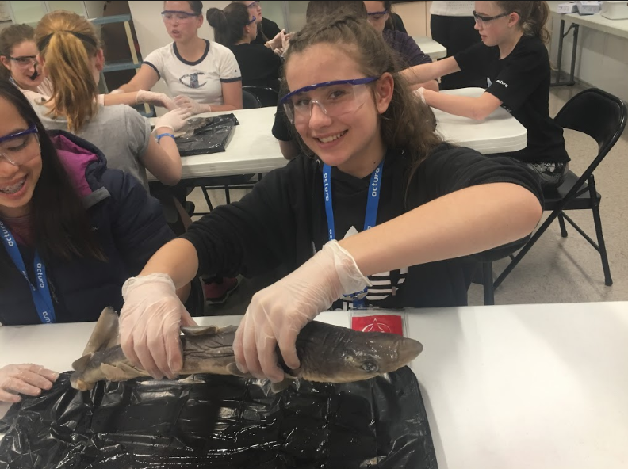
Georgia Viney getting a feel for a Dogfish Shark before they begin the dissection.

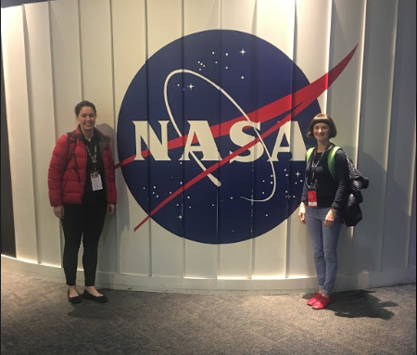
Accompanying teachers Kathleen O’Leary (L) and Felicity Jacobs (R)
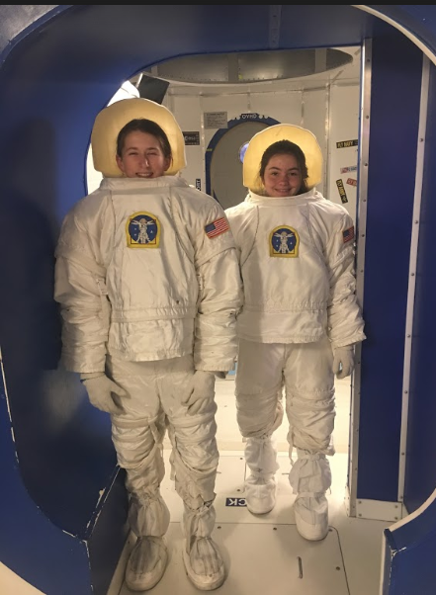
Mena McLeod (L) and Grace Fabris (R) getting ready for the ISS mission.
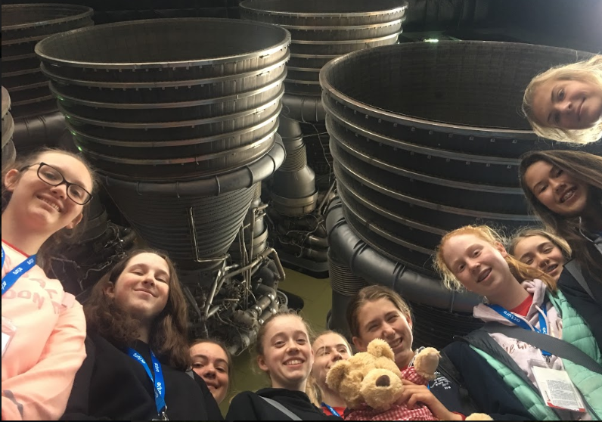
The best classroom ever.
(L-R) Paige Harris, Charlotte Rankin, Grace Fabris, Mia Peatling, Georgia Viney, Mena McLeod, Amelie Lumsden-Steel, Jenna Rogers, Lily Bushby, Grace Bottomley.
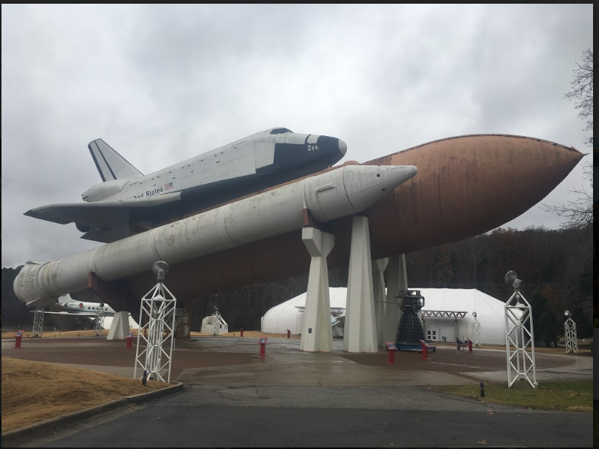
Shuttle with launch rocket take centre stage at USSRC.

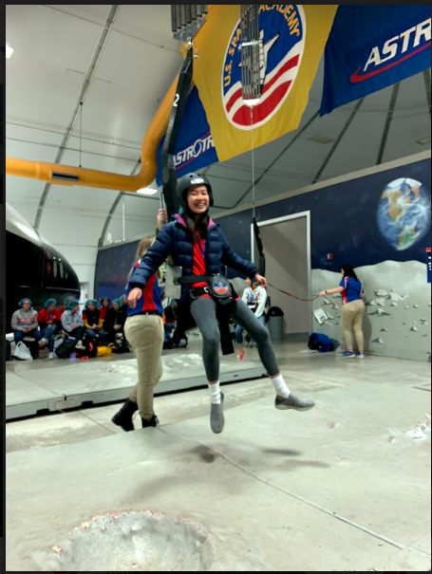
Ashley Walker experiencing 1/6th gravity at USSRC.
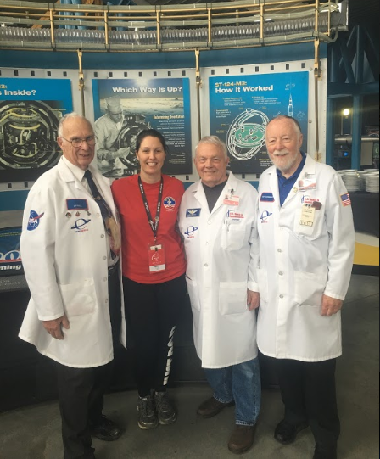
Docents at USSRC.

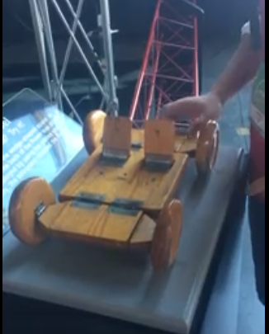
Lunar Buggy folding model.
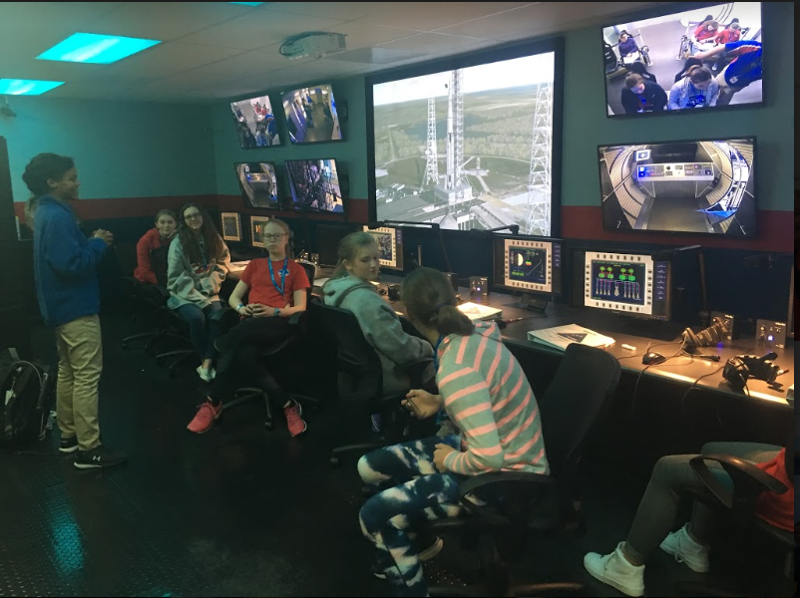
The students having a break before they run the simulation of the Orion mission launching a shuttle to the ISS.

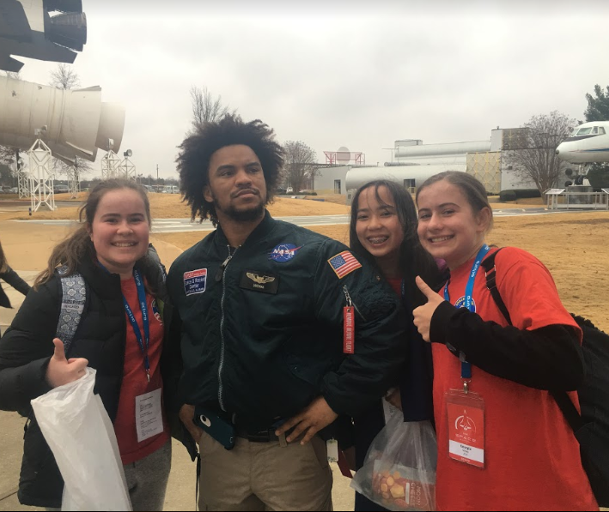
Grace Viney, Douglas, Ashley Walker and Georgia Viney get to hang with their crew trainer and guide.

Where? Where? Wedgie!

This exciting opportunity to be involved in a local citizen science project, complete with great educational resources is now two years old. Established by Dr Clare Hawkins as part of a Nature Trackers and Bookend Trust project, it is a fantastic chance for students and teachers alike to learn about raptors and contribute to Tasmanian conservation.

The free school presentation booking form is now open for the updated 2019 Where? Where? Wedgie! course for Y1-10, AND citizen science project. On 10-12 May, and 24-26 May, Tasmanians of all ages will be raising their eyes to the skies for this year's bird of prey survey. Your school can follow along or even take part, through the teaching materials, videos, photos and discussion boards.
The Where? Where? Wedgie! 2019 courses are now up and ready to view - check them out here: https://expeditionclass.com/learn.php
And also watch two of the eight upcoming videos that accompany the citizen science adventure: https://expeditionclass.com/live.php?expedition=16&day=0
School visits are starting this week, so please BOOK NOW! https://www.surveymonkey.com/r/RTHQ3PP
(We do have a little flexibility so teachers can let us know on the booking form if there’s a different date from those offered which would suit them much better).

More details in our latest update: https://us1.admin.mailchimp.com/campaigns/show?id=3288873
And if people would like to sign up to regular Where? Where? Wedgie! updates for teachers then they can do so here: http://eepurl.com/dkdonX

- Free teaching resources aligned to Australian Curriculum: Science and across other curriculum areas coming out in this month (March 2019). See the introduction including the first video here: https://expeditionclass.com/contentPage.php?id=25
- Optional but highly recommended opportunity to take part in an eagle survey = real world application for classroom learning. 10th, 11th, 12th, 24th, 25th and/or 26th May.
- Free 45 minute school presentations to prepare your students (25th March - 12th April 2019).
- A small number of free professional learning opportunities for teachers to support their involvement in the Where? Where? Wedgie! survey.
- One booking form per school is preferred, so please have a staff room chat and then...
Sign up asap! https://www.surveymonkey.com/r/RTHQ3PP

Scientific Snippets and Discoveries
Recent advances in knowledge worth sharing…

Japanese Space Program Samples Asteroid
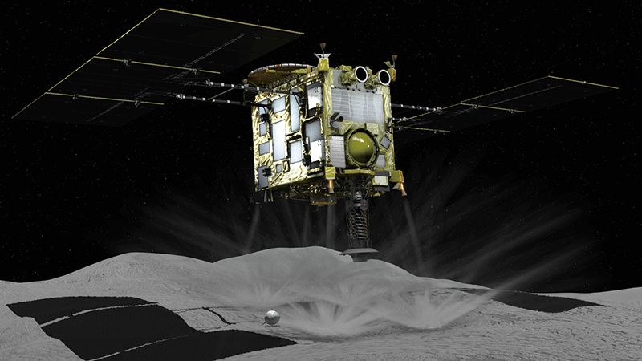
(Image Credit: JAXA)
On the 21st of February, 20 km above the surface of the 1 km wide asteroid Ryugu, Japan’s Hayabusa2 spacecraft began a 26-hour descent onto the surface. Given the low gravitational forces, this was a tricky and delicate manoeuvre, made even more difficult by the potentially damaging boulders at the surface. Previously it had dropped a reflective target as a reference landing point, identified from meticulous analysis of surface photos. The craft honed-in to the chosen spot and landed briefly, firing a projectile into the surface to kick up material, collected in a sampler horn. This material will make its way back to Earth, entering our atmosphere late in 2020. This opens up the possibility for asteroid mining in the future and its success (or apparent success until the samples are returned!) teaches us a lot for future planned missions. https://www.nature.com/articles/d41586-019-00671-3?utm_source=Nature+Briefing&utm_campaign=57b40611f6-briefing-dy-20190321&utm_medium=email&utm_term=0_c9dfd39373-57b40611f6-42715383

Wombat Scats and Manufacturing Cubes
We have all seen cubic wombat scats perched neatly on logs or rocks, wafting their chemical messages through the bush. Place a suitable object in a wombat’s territory and there is a good chance some will be deposited overnight. Until recently, questions surrounded how the wombat manages to produce these neat cubic scats (don’t try this at home). Dr Scott Carver from UTAS sent wombat intestine samples for analysis at the Georgia Institute of Technology, where Dr Patricia Yang measured the pressure of balloons along the empty gut. It was found that the stretchiness of the intestinal wall corresponds to the final eight percent where the liquid contents are solidified and shaped into cubes. This may provide insights into how we could efficiently manufacture cubic shapes out of suitable material for industrial purposes. https://blog.doublehelix.csiro.au/revealed-the-secret-to-wombats-cube-poo/?utm_source=Double+Helix+Extra&utm_campaign=55d5776094-EMAIL_CAMPAIGN_2018_03_01_COPY_01&utm_medium=email&utm_term=0_36b345597f-55d5776094-53724041

Wings Beneath the Ionic Wind
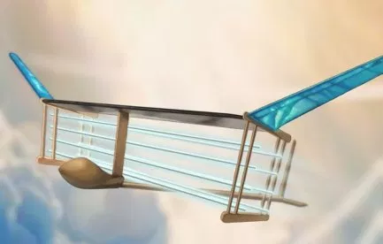

Researchers at MIT have developed an aircraft with no moving parts. 20,000 volts is put through wires at the front, ionising the surrounding air which is attracted towards the negative 20,000 volt charge in wires through the wings at the rear. This ionic wind forces the aircraft forwards. The force is not enough for lift off, so the launch is from a catapult. Initial tests flew 60m, bearing in mind the Wright brothers managed an initial 40m. There is possible potential (if you will excuse the pun) to develop drone technology around this design. https://blog.doublehelix.csiro.au/how-to-fly-without-moving/?utm_source=Double+Helix+Extra&utm_campaign=8029e59d53-EMAIL_CAMPAIGN_2018_03_01_COPY_01&utm_medium=email&utm_term=0_36b345597f-8029e59d53-53724041

Weekend Lie-Ins do not Compensate for Weekday Sleep Deprivation
If you have spent a week staying up late marking, planning, writing, developing resources, researching…the list goes on, you deserve a lie-in at the weekend. However, the lie-in will not compensate the effects of ill-health inherent in a busy lifestyle. A University of Colorado study on young adults (so this applies to students too), found that traits and behaviour linked to diabetes and heart disease such as snacking, weight gain and reduced insulin sensitivity, remained even if the test subjects had a weekend sleep. Those whose weekend regime mirrored that of the hectic week had the similar results to those allowed a lie in, whereas a test group getting nine hours sleep were less inclined towards unhealthy behaviour. Five hours sleep is not enough to ward off these ill-effects, even through catch-up sleep. Six to eight hours is usually recommended, although Einstein slept for 10 hours per night and Winston Churchill got by with a two-hour power nap at 5pm. https://www.nature.com/articles/d41586-019-00723-8?utm_source=Nature+Briefing&utm_campaign=1666d2cd7c-briefing-dy-20190301&utm_medium=email&utm_term=0_c9dfd39373-1666d2cd7c-42715383

New Methods Enabling Volcano Monitoring
There are 800 million people living within 100 km of volcanoes throughout the world, so monitoring and predicting is a key goal for Earth science. However, this process is riddled with difficulties. On-ground monitoring requires a high allocation of resources and remote monitoring from satellites, looking for shifts in ground movements, become distorted by atmospheric conditions. A team from the University of Bristol studied the November 2017 eruption of Agung in Bali using satellite radar data. They found a way to compensate for atmospheric distortions and ‘see’ the 10cm shift in land levels when magma moved to the northern side of the volcano before the eruption. A weather model is now able to predict distortions, taking atmospheric conditions out of the equation and allow greater focus on unusual ground movements. 30,000 images of 900 volcanoes identified 100 areas of interest and found 39 actual earth movements. The computerised neural network can learn to more accurately identify these areas, doubling the precision of the system. Alongside other techniques such as monitoring ash, surface temperature and rate of surface change, we are a lot closer to accurate predictions of eruptions and greater effectiveness of evacuations. https://www.nature.com/articles/d41586-019-00752-3?WT.ec_id=NATURE-20190314&utm_source=nature_etoc&utm_medium=email&utm_campaign=20190314&sap-outbound-id=203C6FCB245F3D48FC1D8FBF5A9961F8FD49FFB7

Observing Evolution: Short-term Changes Seen in Lice and Birds
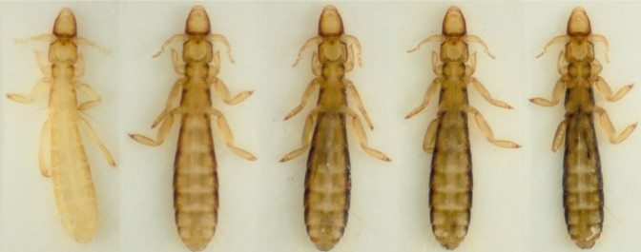
Evolutionary changes are usually associated with tiny increments over millions of years. This is why the example of the Peppered Moth is so favoured by biology textbooks, distilling change into a matter of a few generations. Recently, two similar stories of evolution in macro-organisms in observable timescales have shone a light on adaptations and a new species has emerged. It is appropriate, given that Darwin himself observed changes in pigeons, that a team from the University of Utah also looked to pigeons for an inspired experiment. The domestic Stock Dove has a high degree of variation, including all dark, naturally grey and pure white examples. They also have lice that feed on the feathers. 2,400 lice were placed onto 96 previously fumigated pigeons and left for four years. That is enough time for 60 generations of lice (roughly the equivalent of under 2,000 years for humans) to come and go. On pigeons that preened, the lice underwent evolutionary adaptations by matching their shade to the plumage colour. A poultry bit, preventing preening, was fitted to some pigeons and they ended up with 20 times more lice that did not adapt to the plumage colour. The largely white Australian Pied Imperial Pigeon has a pale feather louse, evolutionary separated for 20 million years from the louse in the experiment. In yet, after four years, the pale lice that evolved, closely resembled the Imperial Pigeon’s louse.
Meanwhile, on Daphne Island in the Galapagos, scientists witnessed the arrival of a male Large Cactus Finch in 1981 that went on to mate with a female Medium Ground Finch. Forty years later, the descendants number around 30 individuals, now described as a separate species. They can no longer interbreed with other species and their behaviour is notably different. Hybrids have long been noted in groups of finches, but this time, fertile offspring and relative isolation has led to speciation and the whole process has been witnessed and monitored.

https://www.theatlantic.com/science/archive/2019/03/unusual-evolutionary-experiment/584692/?utm_source=Nature+Briefing&utm_campaign=db543bc5f4-briefing-dy-20190314&utm_medium=email&utm_term=0_c9dfd39373-db543bc5f4-42715383
https://www.santacruzgalapagoscruise.com/new-species-galapagos-finch/

STATIC QUIZ

Easier:
- What sort of animal is a Meadow Argus?
- Is an Australian Water Rat a marsupial?
- Which of the following should not go in the compost bin; egg shells. bread, coffee, weeds or tea leaves?
- What gas is used to light advertising signs?
- What keeps a tyre inflated?
- What number system is used by computers?
- What colour are the flowers of a Blue Gum?
- Going outwards from the sun, which planet is the next beyond Earth?
- Carbon Dioxide is made of atoms of which two elements?
- Which colour is always on the outside of a rainbow?

Harder:
- Put two element symbols together to make the French word for coffee.
- Who wrote ‘Cosmos’?
- What is our closest spiral galaxy?
- What is the brightest star in the sky?
- Complete the name of the animal: Chocolate Wattled……?
- What is the highest mountain in Africa?
- What colour is Lead Iodide?
- What is Katherine Johnson famous for?
- How many times (approximately) would Tasmania fit into the Australian mainland?
- How many species of lizards are in Tasmania?

And for those thinking completely sideways…
- Which flightless publisher is Emperor of Gen too?
- What is the lowest number to have its letters in alphabetical order?
- If you had 1 million dollar coins and laid them out in a perfect square, how much of that space would not be covered in coins? How many coins would be around the edge? How many would be across the diagonal?

Answers:

Easier:

- Butterfly
- No
- Weeds
- Neon
- Air pressure
- Binary
- White
- Mars
- Carbon and Oxygen
- Red
Harder:
- Calcium and Iron (café)
- Carl Sagan
- Andromeda
- Sirius
- Bat
- Kilimanjaro
- Yellow
- A mathematician featured in ‘Hidden Figures’
- 94
- 17 (16 skinks and the Mountain Dragon)
Cryptic sideways thinking clues only!
- Think in black and white or orange and white
- A John Buchan novel and then…
- A dollar coin has a diameter of 24mm. Work it out for one square, multiply by a million and convert to square meters. For the edge, find the square root for the edge length. Work out the number of coins in the next inner square and take this from a million. For the diagonal, use Pythagoras’ Theorem.

