**Does the Colour Inside a Greenhouse Matter?**

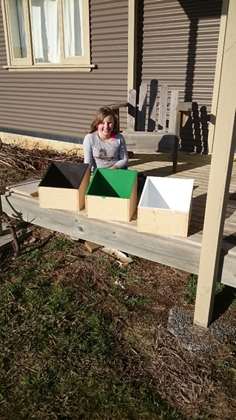

**Delaney Torlop**

Grade 4, South George Town Primary School

**Abstract**

This investigation was designed to find out if colour effects the temperature inside a greenhouse. To test this I built three small-scaled boxes and painted the insides of each box either black, green or white. Then I measured the temperatures inside the boxes over three days. The results were not as I predicted….

**Topic**

How the colour inside a greenhouse effects its temperature.

**Background**

For my investigation I wanted to explore how different colours effect the temperature of objects. For example, my friends and I feel hot in black clothes but not in white clothes. I found out that a black object absorbs all wavelengths of light and converts them into heat so the object gets warm. Whereas a white object reflects all wavelengths of light, so less light is converted into heat, keeping the object cooler. My dad and I planned the experiment using the idea of mini-greenhouses. By building three small-scale greenhouses, each a different internal colour - black, white & green, we could measure and compare the temperature in each greenhouse.

**Question**:

When I change the internal colour of the greenhouse what happens to the temperature inside of the greenhouse?

**Hypothesis**

I think black will be the hottest greenhouse because black absorbs all wavelengths of light and converts them into heat. I think that green will be the second hottest colour because green absorbs every colour except green. I think white will be the coldest because white reflects all wavelengths of light.

**Materials**

Glass, wood, paint, pencil, notepad, glue, nails, computer, thermometers

**Variables:** size of greenhouse, location of boxes, materials used, thermometers

**Independent Variable**: the colour of the inside the greenhouse.

**Dependent Variable**: the temperature inside the greenhouse.

**Procedure**

1. My dad and I built three small-scale greenhouses.

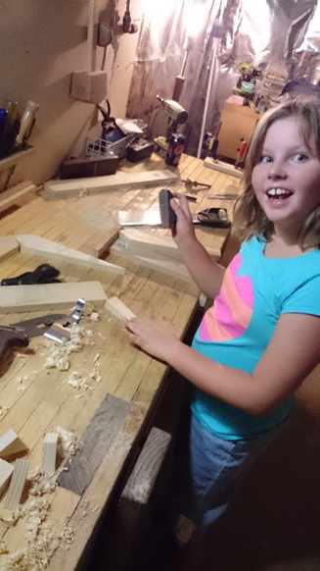

1. I painted the inside of the greenhouses black, green and white.

|  |  |  |
| --- | --- | --- |
|  |  |  |

1. We put glass lids on top and put them in the sun.

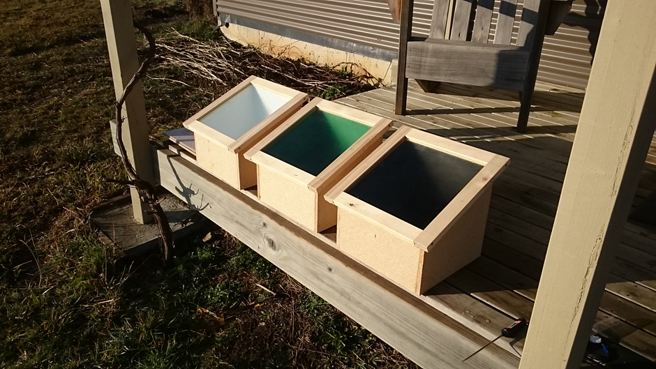

1. We recorded the temperature of the greenhouses every hour during daylight.

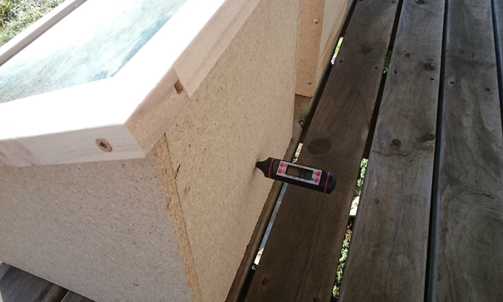

1. I brought them in at night and took the lids off so the heat could escape and the temperature in the boxes was reset for the next day’s test. We repeated the test three times.

**Results**

Average Hourly Temperature (degrees Celsius)

|  |  |  |  |
| --- | --- | --- | --- |
| time | Average of Black | Average of Green | Average of White |
| 9.OO AM | 10.3 | 10.0 | 10.6 |
| 10.00 AM | 19.3 | 19.0 | 20.6 |
| 11.00 AM | 23.6 | 23.0 | 24.6 |
| 12.00 PM | 27.3 | 27.0 | 28.6 |
| 1.00 PM | 26.0 | 25.0 | 26.3 |
| 2.OO PM | 23.0 | 22.6 | 23.6 |
| 3.00 pm | 21.3 | 20.0 | 20.6 |

**Discussion**

The lines on the graph all go up until between 12pm and 1pm and then they all go downhill. I think this is because as the sun rises the boxes get hotter and as the sun goes down and the orientation of the sun to the boxes changes they get colder.

There was not a lot of variation between the temperatures in the boxes.

The data shows that the temperature in the white box got the highest (max 28.6⁰).

The temperature in the green box was the coolest (max 27.0⁰).

The temperature in the black box at the middle of the day was between the green and the white boxes (max 27.3⁰). Interestingly, the temperature at the end of the day in the black box was hottest (21.3⁰).

The results show that my prediction (the black box would get the hottest and the white box the coolest) was wrong. The white box got the hottest.

I think in the white box the sunlight is bouncing off the white walls and off the glass. Light is reflecting around the box and its heat gets trapped and makes the box hotter.

The black box absorbs light because black absorbs all the colours of the rainbow. The light is not reflected around inside the box and therefore the box does not heat up as much.

The black box is warmer at the end of the day because all the light (and heat) has been absorbed. The others cooled down because as the sun goes down there is less light available. Since black does not reflect light it keeps the most heat.

At the end of the day when I was putting the boxes away, the white one felt colder than the black one from the outside.

I would like to test whether less light effects the temperature of the boxes. I would try to block the sunlight by covering two-thirds of the glass with wood so that less light gets in. The coverage would need to be the same for each box. I predict that the white would not be the hottest anymore because there would be less light reflecting around inside the box and so it would not get as hot. The darker boxes would get more chance to be hotter because they absorb light, whereas the white box requires more light to get hot.

**Acknowledgements**: Anthony Torlop - My dad help me do the science investigation, Lu McGinniss (class teacher) helped me do the typing.