Creeky Growths
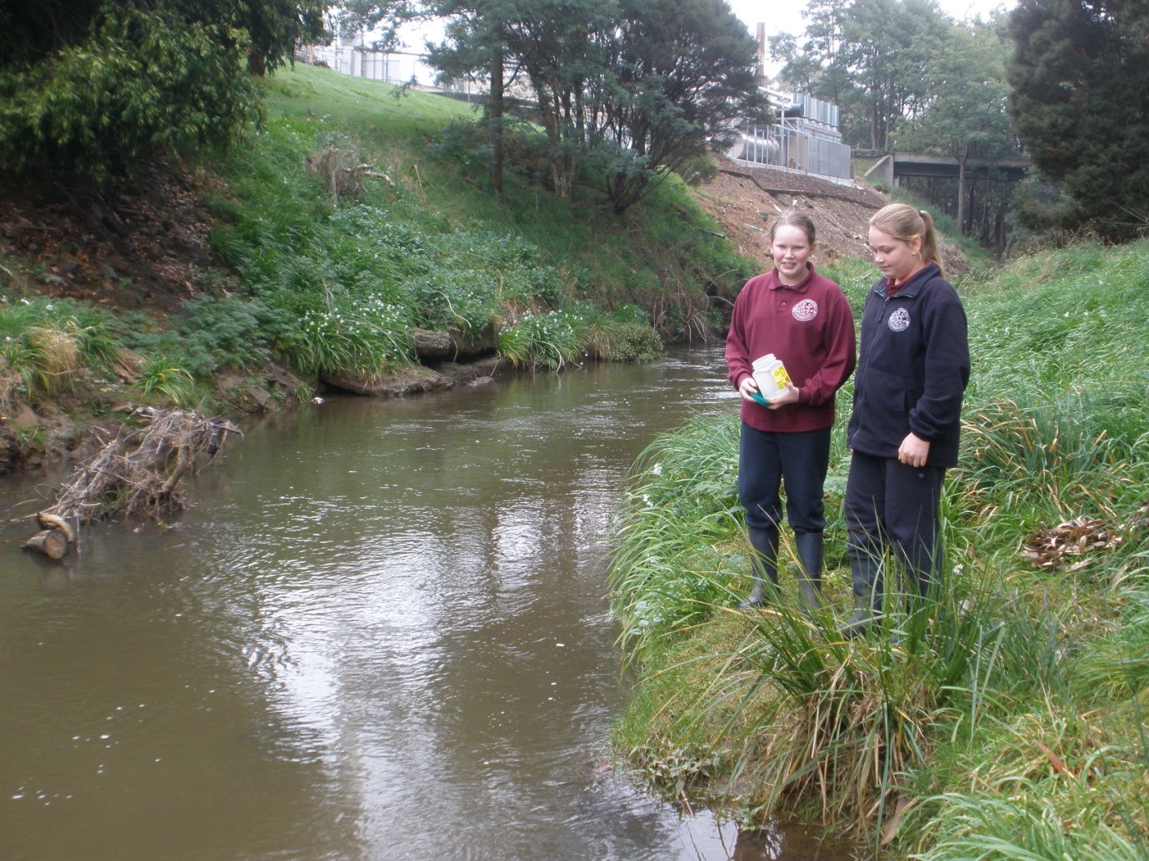

Grade 5
Table Cape Primary School

Topic
The growth of alfalfa using water samples taken from local creeks and rivers.

Abstract
Around Wynyard there are many creeks and rivers. We were wondering how well their water would grow alfalfa seeds. We predicted that Big Creek Site 2 would grow the best alfalfa seeds because it was surrounded by natural bush lands. Our results show that the alfalfa seeds grew best with the sample of water taken from Big Creek Site 2. They grew the least amount taken from Big Creek Site 1 which was near a local factory.

Background: Collection Sites
Water Way | Description of Sample Site | Picture of Water Sample Site
Big Creek Site 1 | -Near an local factory and road  -Bank cleared and grassy | 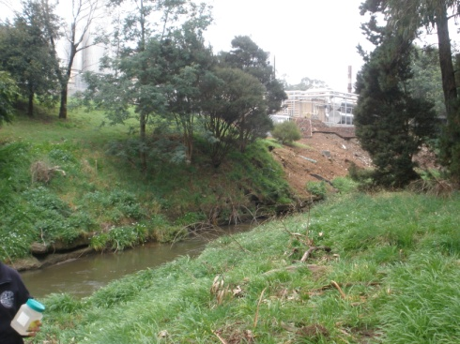
Big Creek Site 2 | -Natural bushland  -Near major highway | 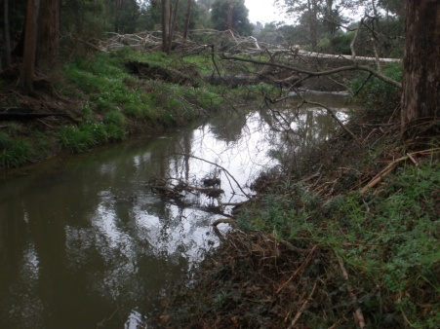
Camp Creek | -Surrounded by paddocks  -Near major highway | 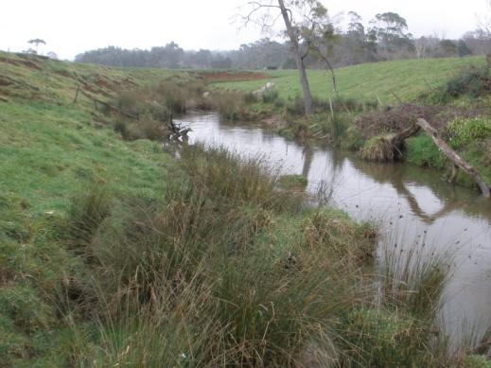
Port Creek | -Surrounded by dense coverage of tea-trees  -Near the sea | 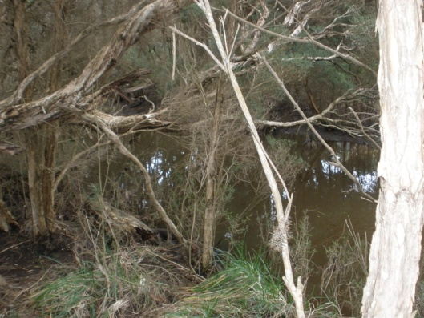
Inglis River | -Major water way flowing into Wynyard  -Wide expanse of water  -Cleared land near the banks | 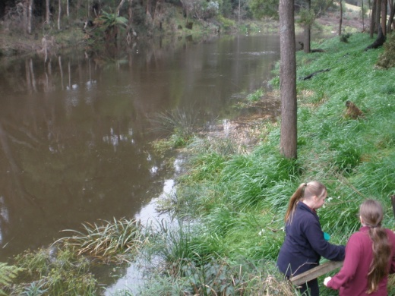

PH – PH measures acid to base (alkaline) level on a scale from 1.0 to 14.0 with 1.0 being the highest acid competition and 14.0 being the highest base. Alfalfa prefer a level between 6 and 7.

Scientific Question
Which water way sample produces the largest amount of growth in alfalfa seeds?

Hypothesis
We think that the water collected from Big Creek Site 2 will grow the best alfalfa seeds.
We base our hypothesis on the fact that Big Creek Site 2 because it was surrounded by natural bushland.

Materials
Trays
Paper towel
Measuring cylinder
Alfalfa seeds
Water Samples
Ruler

Procedure
- Collected water samples from 5 different water ways
- Collected a sample of tap water as a control
- Place paper towel in trays
- Place alfalfa seeds on trays
- Measure 10ml of water from samples to add to each tray
- Water each sample tray once every two days with 10ml of water
- Measure and record growth from root to tip after 1 week then 2 weeks from 5 of the tallest alfalfa seeds from each tray
- Count seeds that have sprouted after 2 weeks

Control Variables
- Grown on paper towels
- Watered at the same time with 10ml of sample water
- Kept in the same place (self in room at approximately 22 degrees)
Independent Variable
- Water samples used
Dependent Variables
- Growth rate of alfalfa seeds
- Strike rate of alfalfa seeds

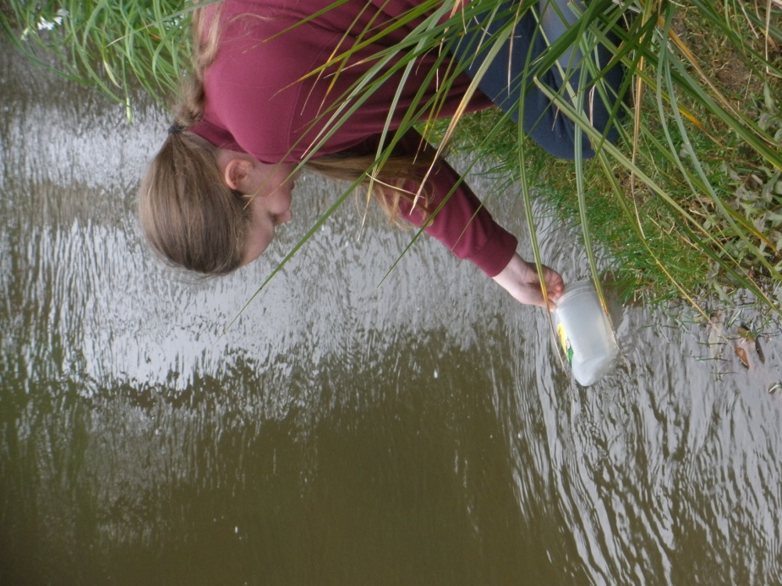
Taking Water Samples

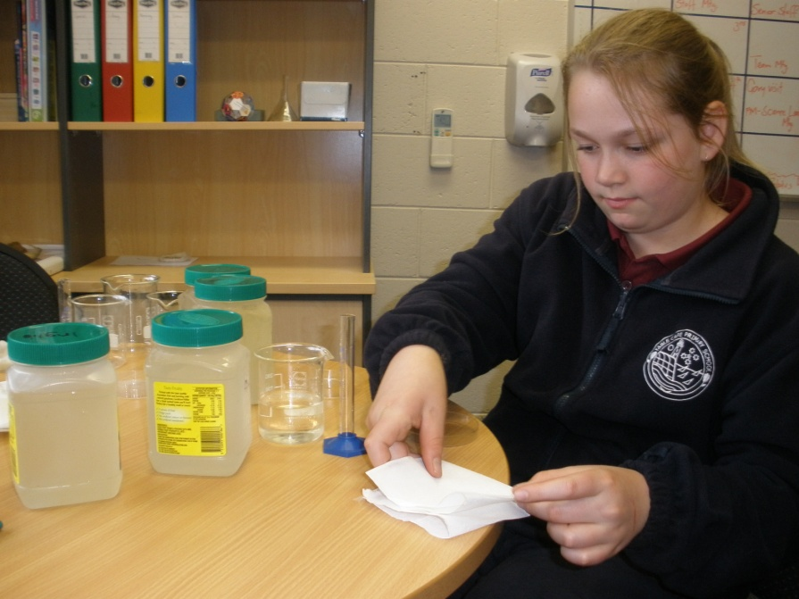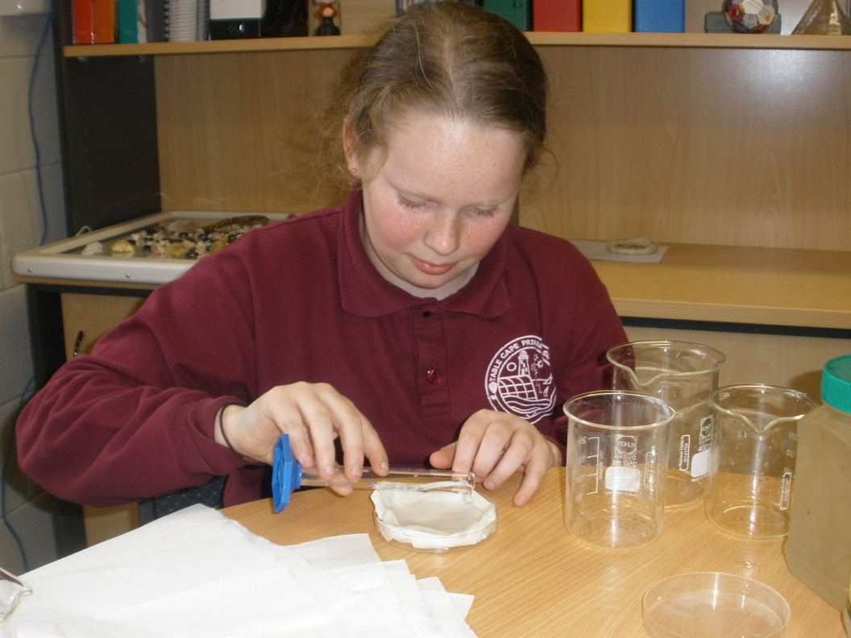
Measuring Water Samples Preparing Tray

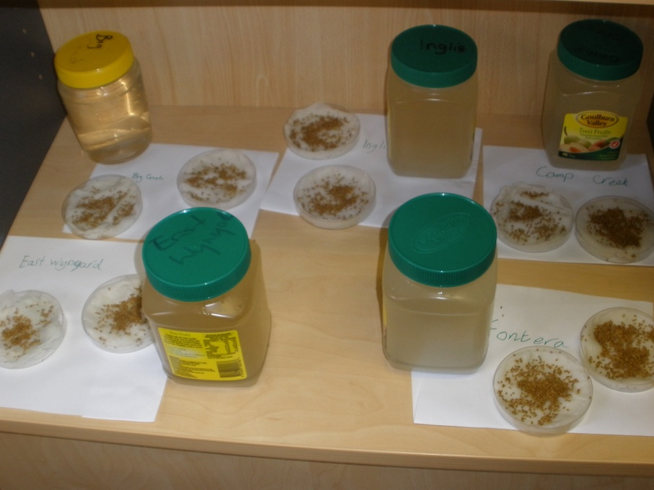
Water Samples with Seeding Trays

Alfalfa Seeds Growing in Trays

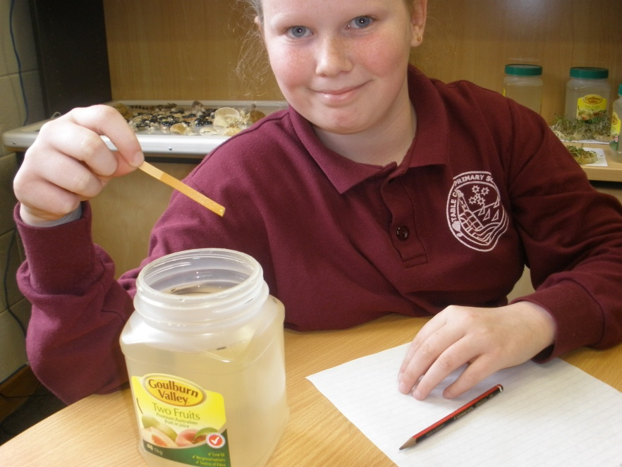
Testing PH of the Water

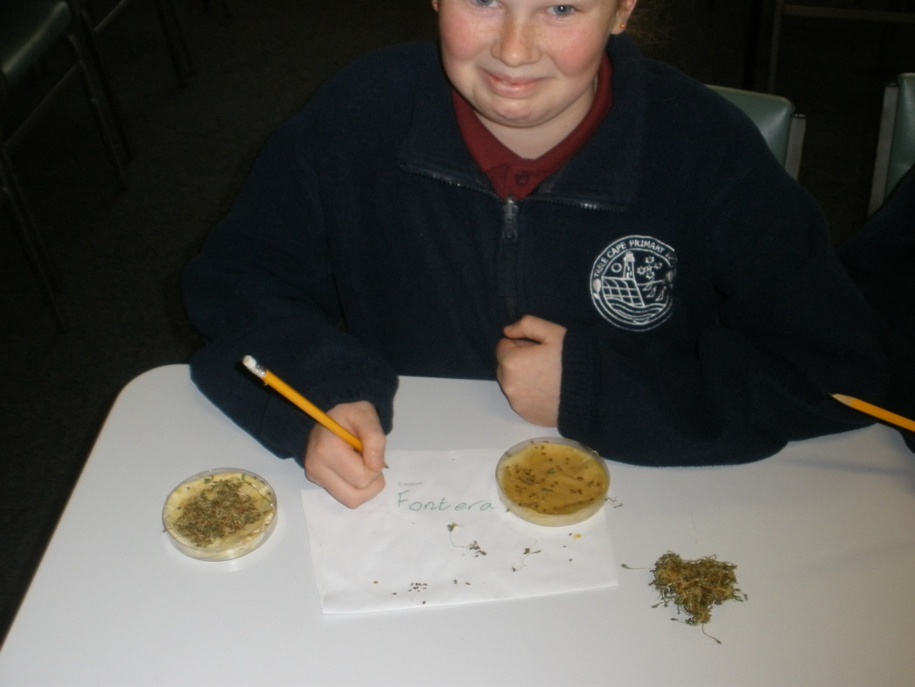
Recording Seed Strike Rate

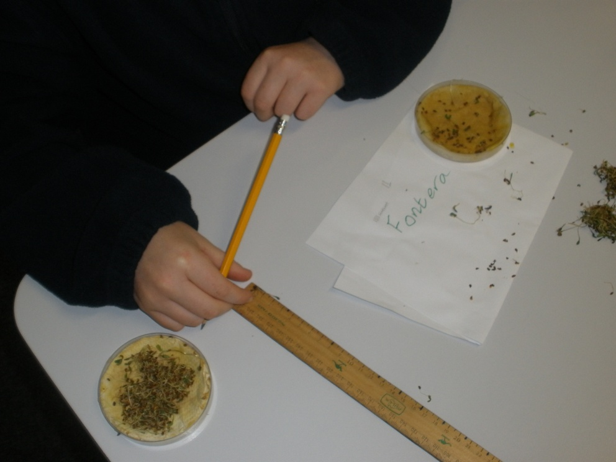
Measuring Growth

Data
Average Growth (centimetres) Week 1
 | Tap Water | Big Creek  Site 1 | Big Creek  Site 2 | Camp  Creek | Port Creek | Inglis River
Tray 1 | 4.4 | 3.8 | 5.2 | 3.0 | 4.0 | 5.0
Tray 2 | 4.2 | 3.3 | 5.0 | 4.1 | 4.0 | 4.4

Average Growth (centimetres) Week 2
 | Tap Water | Big Creek  Site 1 | Big Creek  Site 2 | Camp  Creek | Port Creek | Inglis River
Tray 1 | 5.6 | 4.2 | 6.2 | 4.9 | 5.7 | 5.2
Tray 2 | 5.7 | 5.0 | 6.6 | 5.7 | 5.5 | 5.5

Percentage of Alfalfa Seed that Grew
(Number of alfalfa seeds counted)
 | Tap Water | Big Creek  Site 1 | Big Creek  Site 2 | Camp  Creek | Port Creek | Inglis River
Tray 1 | 70 (80) | 63 (107) | 71  (109) | 55  (86) | 64  (78) | 58  (92)
Tray 2 | 68 (93) | 67  (84) | 59  (104) | 56  (84) | 71  (85) | 55  (98)

Site | PH Result
Tap Water | 6
Big Creek Site 1 | 6
Big Creek Site 2 | 6
Camp Creek | 6
Port Creek | 6
Inglis River | 5

Alfalfa grows best in a PH of 6 to 7.

Analysis/Conclusion
Our hypothesis stated the water collected from Big Creek Site 2 will grow the best alfalfa seeds.
We base our hypothesis on the fact that Big Creek Site 2 because it was surrounded by natural bushland.

Our results show that our hypothesis was correct.

The worst performing site was Camp Creek Site 2 near a local factory.

The PH of each waterway was around 5 and 6.

The best performing sites for alfalfa growth were Big Creek 2 and Port Creek. These performed even better than the seeds grown in tap water. The two creeks (Big Creek 2 and Port Creek) were surrounded by natural bush lands than the other sites. We believe that the creek water running through these natural settings contained material that was more conducive to plant growth than the creeks that were running through land that had been cleared. These bushland creeks also contained less chemicals than the tap water which might of inhibited the growth of alfalfa seeds.

The largest percentage of seeds that grew from the two trays were those watered from the tap. We believe that this maybe because the chemicals found in tap water may be responsible for producing a higher strike rate than those watered from a natural source.

If we did this again we would try different waterways on alfalfa seeds and use different plants. We would also investigate the properties of our local tap water and compare different tap waters from around the region in regard to growth of alfalfa seeds.

Bibliography
http://www.uwex.edu

